government degree COLLEGE
kukatpally
Profile
Department of Library
INTRODUCTION

College library is the heart of institution. An academic library is a library that is attached to a higher education institution and serves two complementary purposes: to support the curriculum, and to support the research of the university faculty and student It supports the process of college education through providing required reading materials to the user and opens the doors to the wide world of books which encourages reading for gain of knowledge and pleasure. College library is also used for recreation and leisure as it provides light reading materials like magazines, novels etc.

The college library was established in the year 2014 The library holds a collection of nearly 4000 books which covers all the conventional and restructured subjects, languages, literature and also books for general reading etc.

The main objectives of the Library are

1. To provide and supplement the curriculum taught in the institution;
2. To give students a wider and deeper understanding of the universe of knowledge
3. Provide career employment information resources to the users
4. Provide access to Internet, OPAC, and e-resources
5. To assist the teaching staff in the pursuit of higher studies and research and support them with relevant literature and information on the subject
6. To inculcate reading habits at the initial crucial stage so that the students become regular and effective users of future and face the competitive world.

Library building
Library is presently accommodated in the central hall along with staffroom, and a corridor.
Library Timings: The library is open from 12:00pm to 6:00pm

ACQUISITION POLICY:-

Books are purchased under approval of Library and Reading Room committee (LRR COMMITTEE) Budget is distributed among all the departments. Indents are acquired from the In-charges of all departments. As per the available budget orders are placed with approved book suppliers and books are purchased. The following grants & funds will be utilized for the purchase of library books, journals Periodicals and newspapers
- Library special fee fund of college
- State Government budget
- Special fee of self finance courses / restructured courses

Library Reading Room Committee
- Dr.N.Alivelu Mangamma,Principal,Chairman
- Smt.M.Karuna,Convener
Members
- Dr.G.Geetanjali,Asst.Prof of Biotechnology
- Dr.M.RameshBabu,Asst. prof of Telugu
- Dr.G.Dayanand Arya,Asst Prof of Hindi
- Smt.Rajitha,Lecturer in English.

Collection of Library :
The library holds a collection of 4212 books which include 3443 Books and 769 donated books
Number of Titles : 664
SNO | SUBJECT | NO OF BOOKS
1 | BIOTECHNOLOGY | 48
2 | BOTANY | 136
3 | CHEMISTRY | 440
4 | COMMERCE | 894
5 | COMPUTER SCIENCE | 25
6 | ECONOMICS | 212
7 | ENGLISH | 14
8 | ENVIRONMENTAL SCIENCE | 11
9 | GENERAL | 69
10 | HISTORY | 135
11 | MATHEMATICS | 316
12 | MICROBIOLOGY | 30
13 | PHYSICS | 237
14 | POLITICAL SCIENCE | 193
15 | PUBLIC ADMINISTRATION | 62
16 | GENDER SENSITISATION | 37
17 | STATISTICS | 221
18 | TELUGU | 142
19 | ZOOLOGY | 146
20 | HINDI | 75
 | TOTAL BOOKS | 3443

NEWSPAPERS
Library subscribes to 4 newspapers
ENGLISH: 1.THE HINDU
2. DECCAN CHRONICLE
TELUGU: 1.NAMASTHE TELANGANA
2. EENADU

List of Journals /magazines subscribed:
- Current science
- University news
- Employment news
- Pratiyogita darpan
- Competitive success review
- Vijetha competitions
- musi

LIBRARY AUTOMATION:
Library is partially automated with NEWGENLIB Open source software .running with cataloguing; opac module. Further bar coding is in process for circulation mode.
Computers in Library: 1server
Printers: 1

EXPENDITURE STATEMENT OF BOOKS PURCHASED
SNO | YEAR | BUDGET | BILL NO DATED FOR RS. | NAME OF FIRM | NO OF BOOKS PURCHASED | ACCESSION NUMBER | Amount
1 | 2016-2017 | GOVT BUDGET | 0216034155 DT.17.12.2016 RS.1,20,649 | TELUGU ACADEMY,HYDERABAD | 961 | 1 -961 | 1,20,649
2 | 2016-2017 | GOVT BUDGET | 0216034156 DT.17.12.16 RS.25,704 | TELUGU ACADEMY,HYDERABAD | 151 | 961-1112 | 25704
3 | 2016-2017 | GOVT BUDGET | 0216034157 DT.17.12.16 RS.28,891 | TELUGU ACADEMY,HYDERABAD | 273 | 1113-1386 | 28891
4 | 2016-2017 | GOVT BUDGET | 0216034158 DT.17.12.16 RS.10852 | tELUGU ACADEMY,HYDERABAD | 73 | 1387-1458 | 10852
5 | 2016-2017 | GOVT BUDGET | A000106 18.3.2017 RS.30,600 | HIMALAYA PUBLISHING HOUSE,HYDERABAD | 204 | 1459-1662 | 30600
6 | 2016-2017 | GOVT BUDGET | BS/33501 15.3.2017 19,909 | THE BOOK SYNDICATE,HYDERABAD | 55 | 1663-1717 | 19909
7 | 2016-2017(supplied in 2019) | GOVT BUDGET | 0219056362 dt.18.2.2019 for rs.52483 | TELUGU ACADEMY,HYDERABAD | 412 | 1718-2129 | 52483
8 | 2016-2017(supplied in 2019) | GOVT BUDGET | 0219056363 dt.18.2.2019 for Rs.1347.25 | TELUGU ACADEMY,HYDERABAD | 41 | 2130-2170 | 1347
9 | 2019-2020 | DONATED BOOKS | 121613 | LIONS CLUB, BANK OF BARODA,BHARATVIKAS PARISHAD,DEEKSHA PROJECTS | 578 | 2171-2749 | 121613
10 | 2020-2021 | SPECIAL FEE | 61789 | TELUGU ACADEMY,HYDERABAD,AMAZON | 498 | 2750-3248 | 61789
11 | 2021-2022 | SPECIAL FEE | 162 datd28.5.2022 for Rs.22104 | HIMALAYA PUBLISHING HOUSE,HYDERABAD | 110 | 3249-3358 | 22,104
12 | 2021-2022 | SPECIAL FEE | 282 dt.27.5.2022 for Rs13260. | KALYANI PUBLISHERS,HYDERABAD | 85 | 3359-3443 | 13260

LIBRARY SERVICES:
Lending Services: All the students of the college are issued 3 books each for period of 1 semester.
Reference service: reference service is provide to both students and staff.
Newspaper clippings: Newspaper clippings about college are maintained in the library.
Previous question papers are available in the library for the use of students.
PG entrance papers on all subjects are maintained in the library
Competitive material for various exams is made available to students of college for reference.
The college Library maintains a Library Blog which provides links to all the open educational resources like books, journals and periodicals .PG entrance question papers and upsc preparation material is provided.
LIBRARY BLOG : https://librarygdckukatpally.blogspot.com

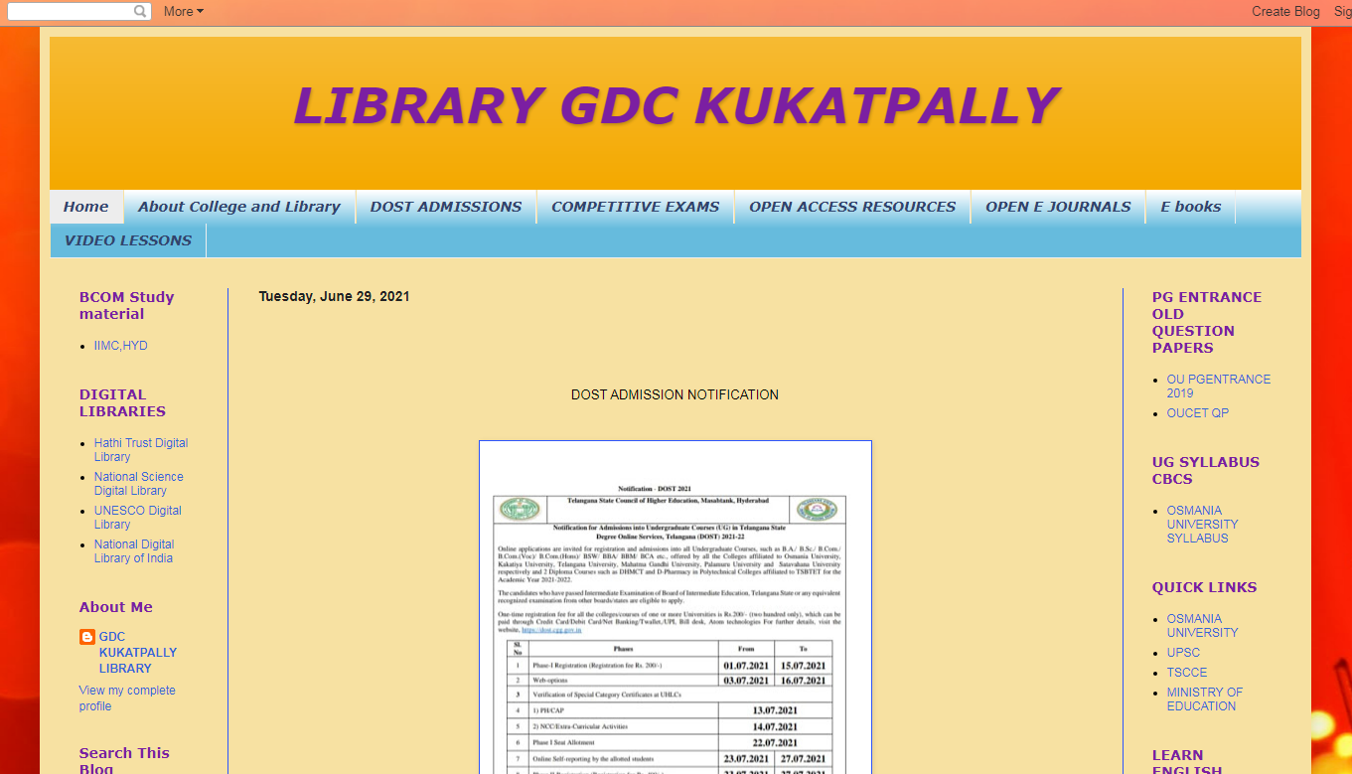

PERSONAL PROFILE
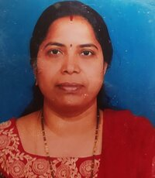
NAME: M.KARUNA
DESIGNATION: LIBRARIAN
QUALIFICATIONS: MLISc, SLET (PhD)
DATE OF APPOINTMENT: 18/07/2009
EXPERIENCE:
1. Worked as Junior Assistant/Senior Asst at Regional workshop, khairthabad,Irrigation Department from 16.7.1999 to 17.7.2009
2. Worked as Librarian at Government Degree College, Siddipet from 18.7.2009 to 9.8.2012
3. Worked as Librarian at Government Degree college, Gajwel from 09.8.2012 to 30.6.2018
4. Working as Librarian at Government Degree College, Kukatpally
Since 30.6.2018
ORIENTATION AND REFRESHER COURSES COMPLETED:
- Refresher Course In Library And Information Science in 2009 at UGCHRDC Osmania university, Hyderabad.
- Orientation course at JNTU,HRDC,kukatpally in j 2012
- Online refreshers course in computational social sciences organized by UGC HRDC Osmania University from 14.12.2020-29.12.2020.
- 2 Day National Online FDP On “Open Learning With Open Online Tools Organized By IQAC,Govt.College Autonomous,Rajamundry,Ap 3,4 May 2020 .
- Completed a MOOCs course on Information Handling skills for Teaching, learning,and research from 26.8.2020-16.9.2020 by Prof.jayashankar Telangana state agricultural university under ICAR,NAHEP.
- One week FIP online short term course on ICT Tools in Higher Education by UGC, HRDC, RUSA, OU, HYD.
- SWAYAM ARPIT COURSE in Emerging trends in Library and information science in February 2020

Seminars/workshops attended:10

