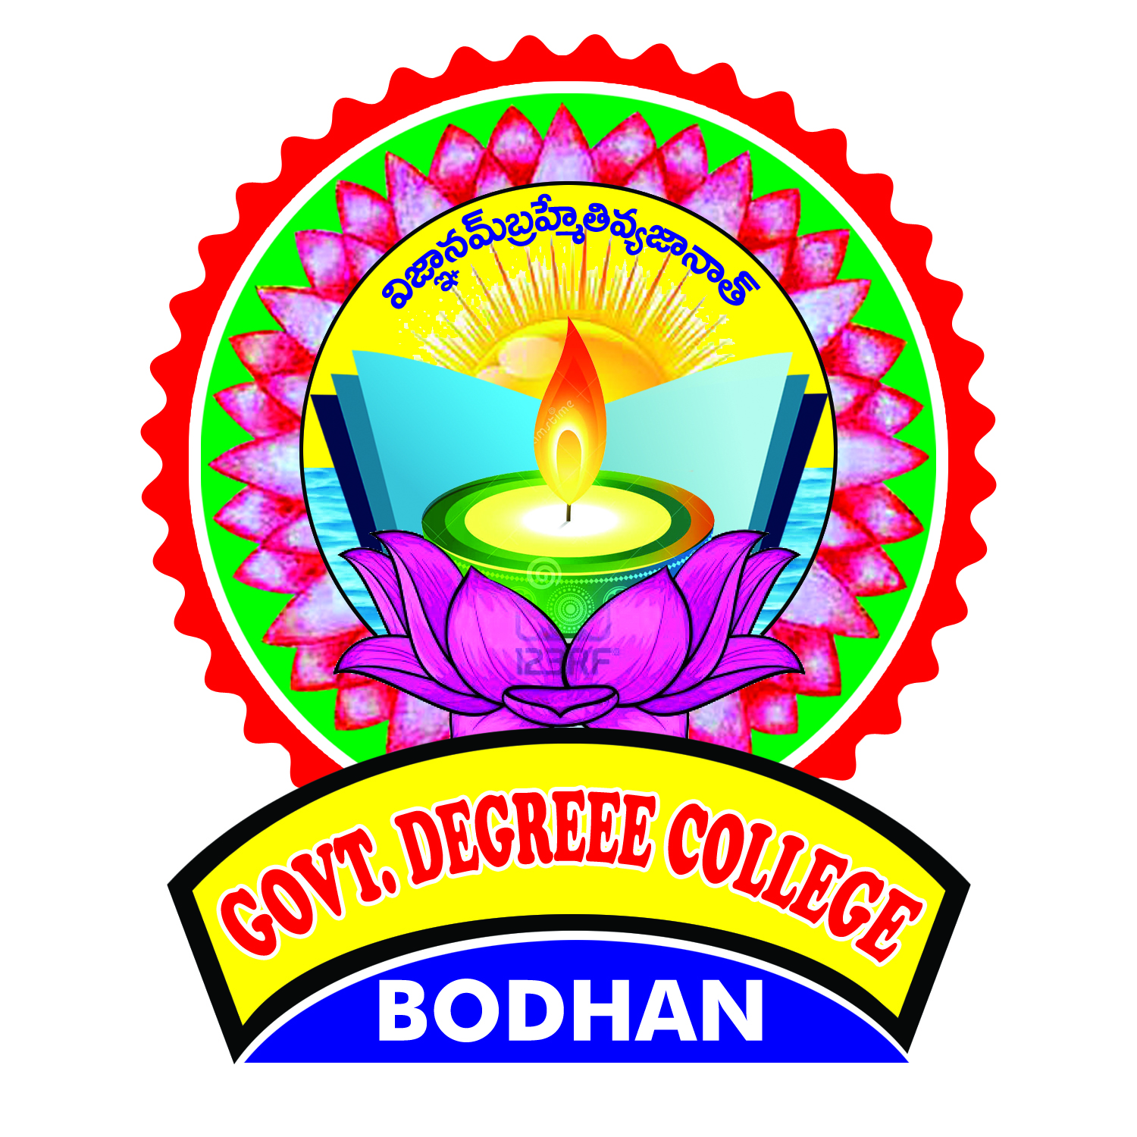
GOVT. DEGREE COLLEGE, BODHAN
ALUMNI FEED BACK

Name of the Alumni : ______________________________________
Address : ______________________________________
Contact Number : ______________________________________
Name of the Course Completed : ___________________________________
Year of Completion : ______________________________________
Occupation / Designation : ______________________________________
Excellent Very Good Average Poor Good
1) How do you rate the courses course
that you have learnt in the college in
relation to your current job or occupation

2) Infrastructure & Lab Facility :

3) Faculty :

4) Canteen facilities :

5) Library :

6) Office Staff :

7) Hostel Facility :

8) Educational Resources :

9) Admissions procedure :

10) Do you feel proud to be associated with modern college as alumni? Yes / No

11) Are you a member of Alumni Association? Yes / No

12) Do you have any grievances with the college? Yes / No

13) As a student / As an alumni please specify / Indicate the grievance:
14) I what way the development activities organized by the college contributed to your over all development : _________________________________________________________
__________________________________________________________________________

15) Any other suggestion : ____________________________________________________

