4.4.2 - There are established systems and procedures for maintaining and utilizing physical, academic and support facilities - laboratory, library, sports complex, computers, classrooms etc.

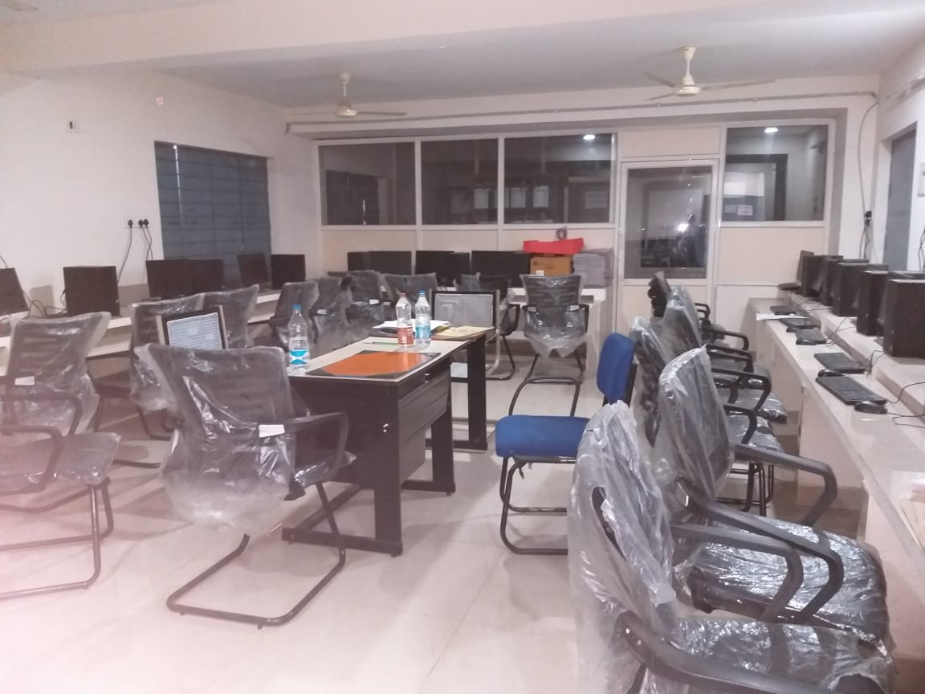
COMPUTER LAB
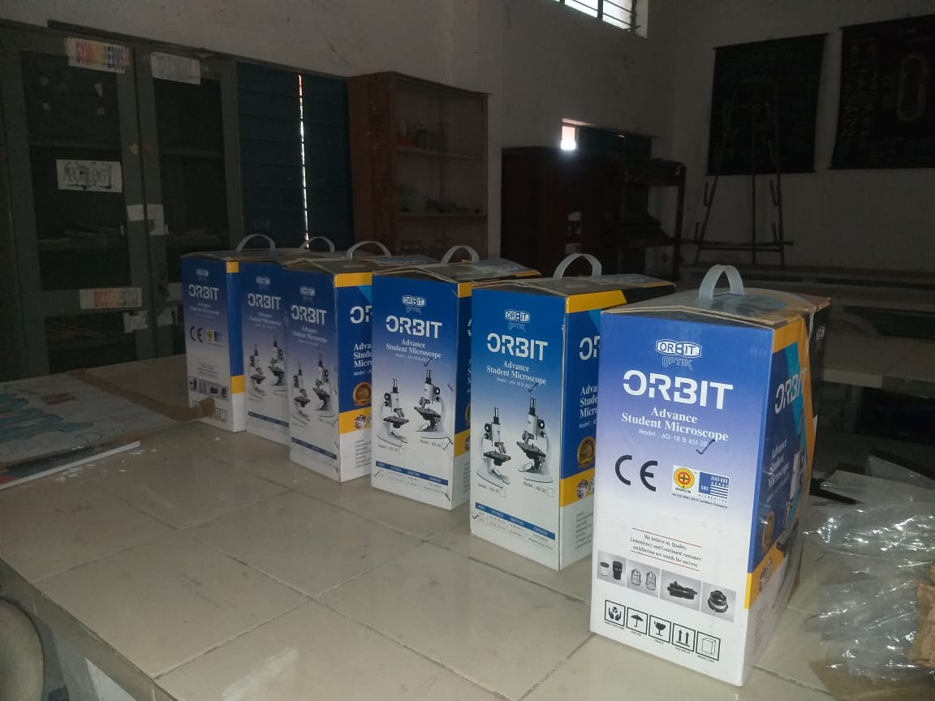
BOTANY LAB
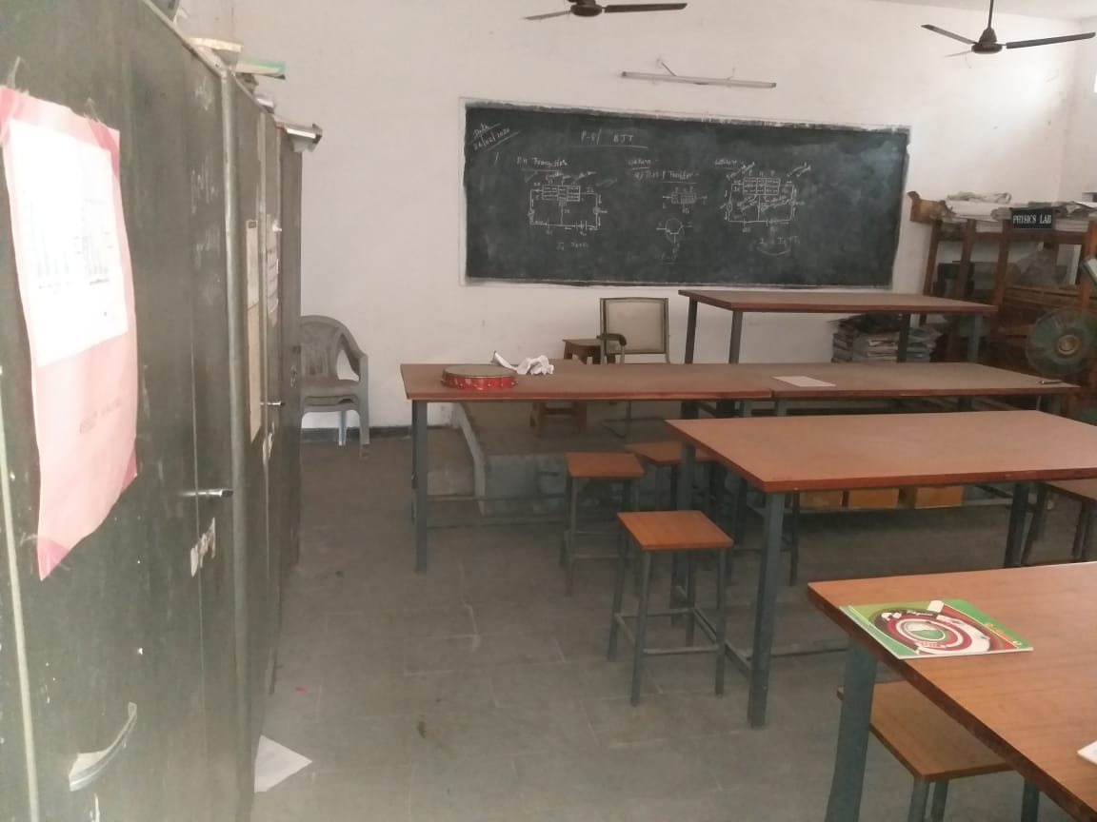
PHYSICS LAB
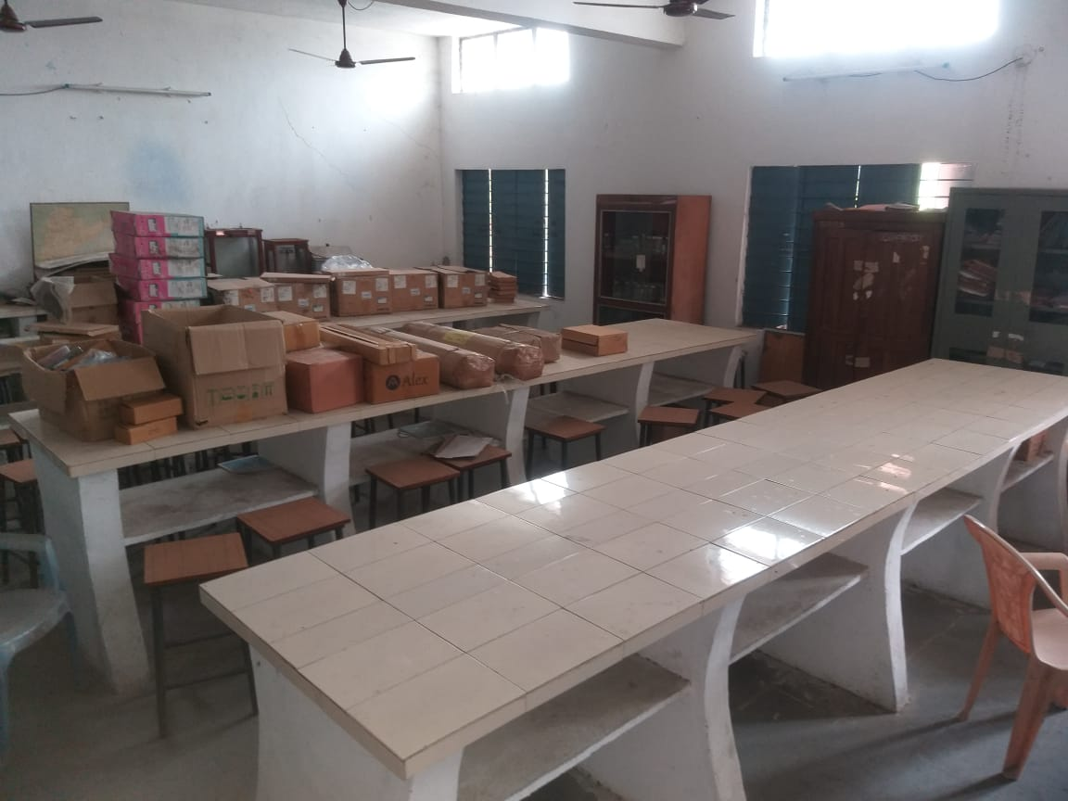
ZOOLOGY LAB

