INFRASTRUCTURE REPORT

INTERNAL QUALITY ASSURANCE CELL (IQAC)
GOVT.DEGREE COLLEGE -BODHAN
NIZAMABAD – TELANGANA

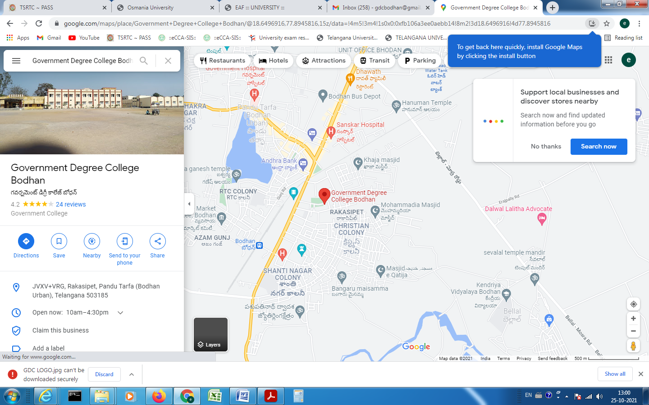

Fig1. Location of GOVT.DEGREE COLEGE - BODHAN

Physical, Academic and Support Facilities available in the Institution
The utilization of physical, infrastructure, sports, library and support service facilities have firmly established norms. The policies and procedures are broadly governed by the orders and instructions of the state government. However these are formed and implemented through staff council and various committees of the college.
The laboratory fee committee decides the allocation of laboratory fee to various departments. The student strength and nature of expenditure (recurring and non-recurring) are taken into consideration. The inventory is regularly done. Annual staff verification is done. The heads of department reassess the needs corresponding to changes in syllabi and condition of equipment. The purchase of new equipment and disposal of absolute equipment is done in accordance with government rules.
The infrastructure is provided by the government. The policies are formed and procedures are laid out. However the maintenance is done through college committees involving the physical director and NSS programme officers. Staff council reviews the status and submits proposals for acquisition, up gradation and creation of infrastructure.
The sports committee and library committee formulate the policies. These decide the timings and general functioning of the facilities.
The following Facilities available in the College

Physical Structure
The available land of the college: 07.75 ACRES
The built-up area of the college: 1.07SQ. ACRES

No. of Class Rooms | 27
No. of Laboratories | 05
No. of Conference halls | 01
Digital Library | 01
Library – Reading Room | 01
Library Stack Rooms | 02
Auditorium | NIL
Canteen | 01
Any other(please specify)(Toilets) | 06

Sl. No | Electrical appliances/instruments | Number
1 | TUBE | 150
2 | LED BULB | 19
3 | PROJECTOR | 6
4 | SPEAKERS | 4
5 | FAN | 100
6 | COMPUTER | 100
7 | LAPTOPS | 4
8 | PRINTERS | 8
9 | PHOTOSTAT machine | 6
10 | SCANNER | 2
11 | UPS | 6
12 | A/C | 5
13 | REFRIGERATOR | 3
14 | TABLE FAN | 3
15 | CENTRIFUGE | 1
16 | EXHAUST FAN | 4
17 | INCUBATOR | 1
18 | DISTILLATION UNIT | 0
19 | CCTV DVR | 2

S.No | Available List | Number | Area occupied
01 | Garden | 01 | 2 ACREAS
02 | Playground | 01 | 4 ACREAS
03 | Toilets | 6
04 | Class rooms | 27
05 | Laboratory | 5
06 | Car/ Scooter shed | NIL
07 | Office rooms | 06
09 | Hostel | NIL | NIL
10 | Canteen | 01 | 80.118 Sq.mts
11 | Auditorium | NIL | NIL

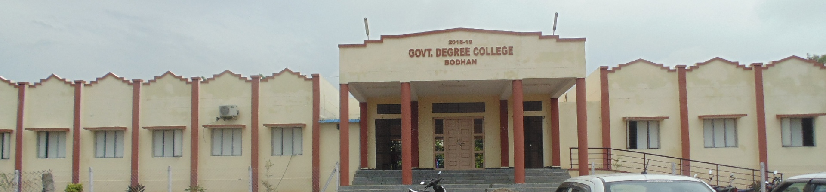

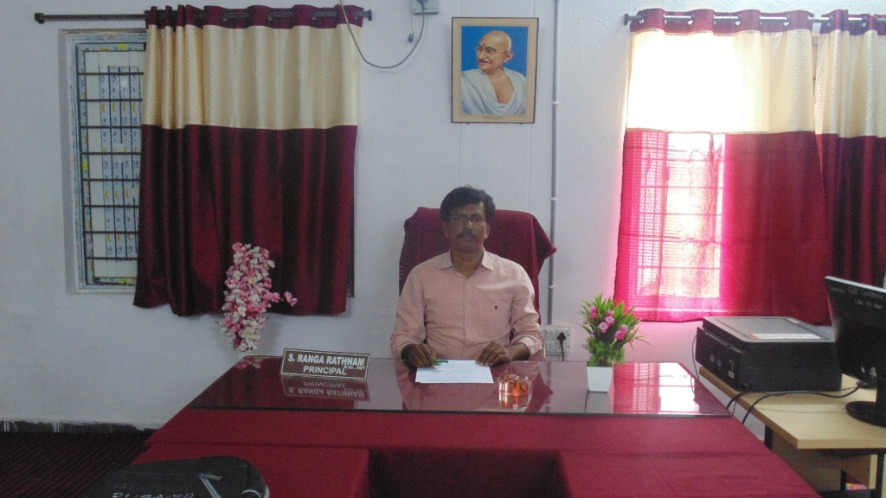

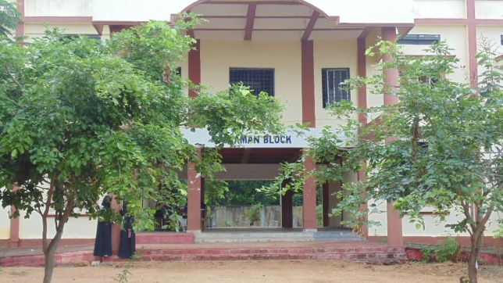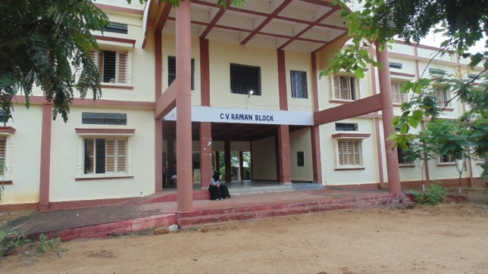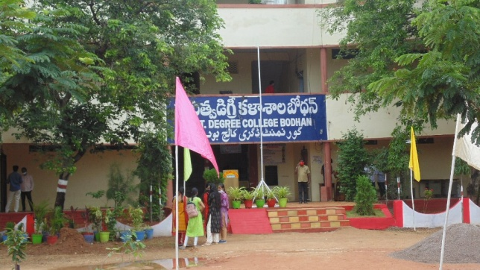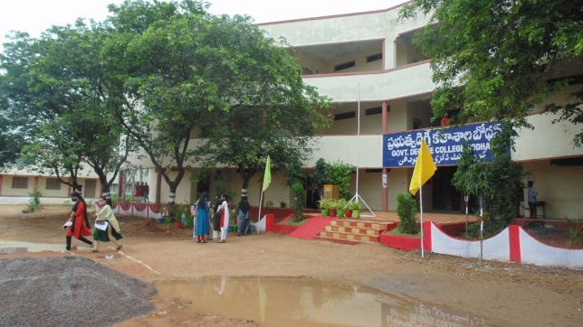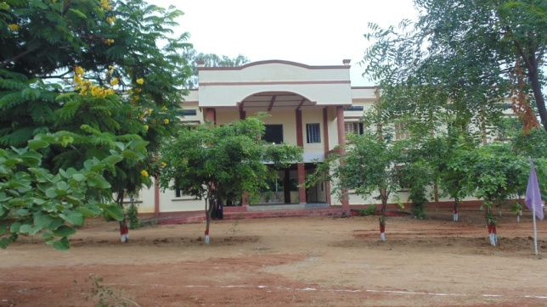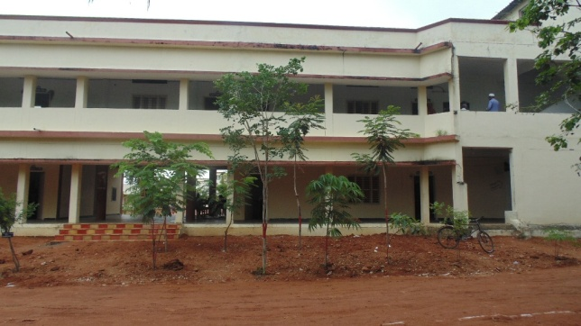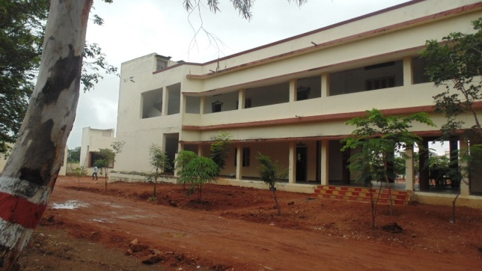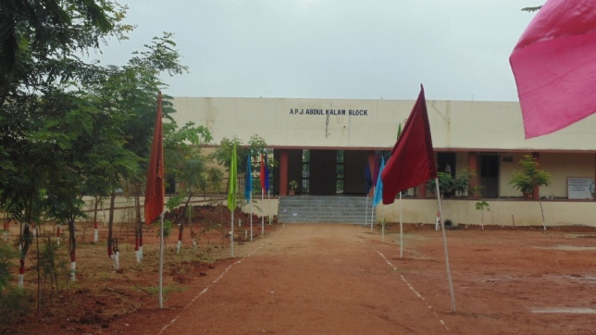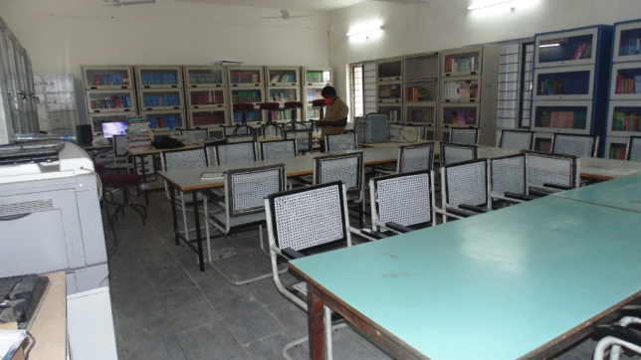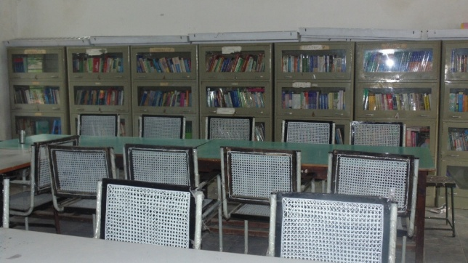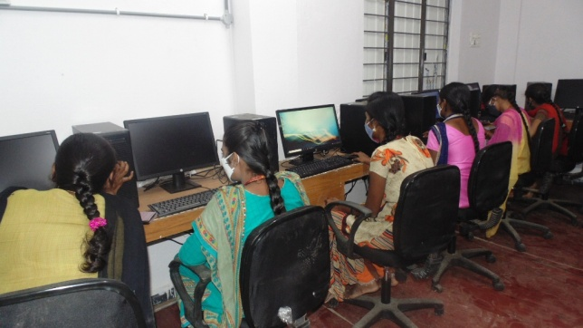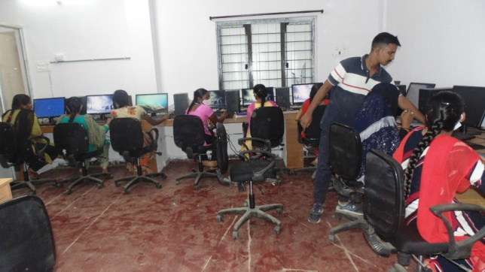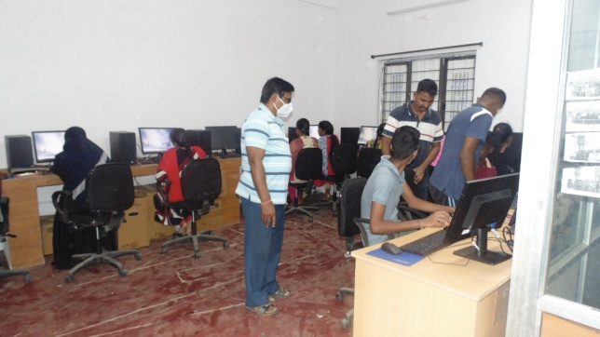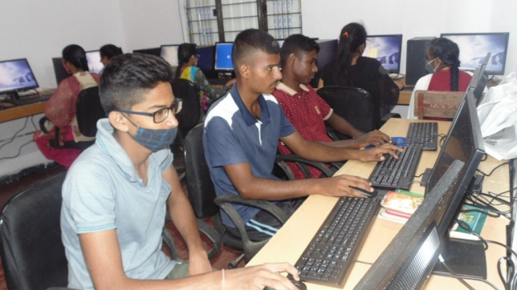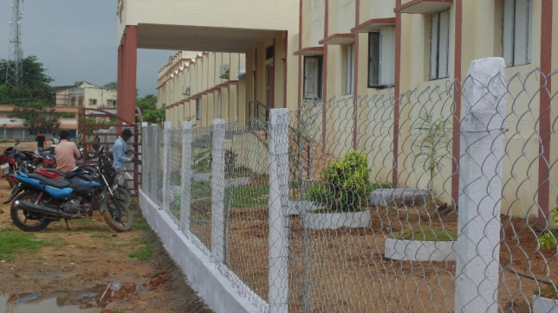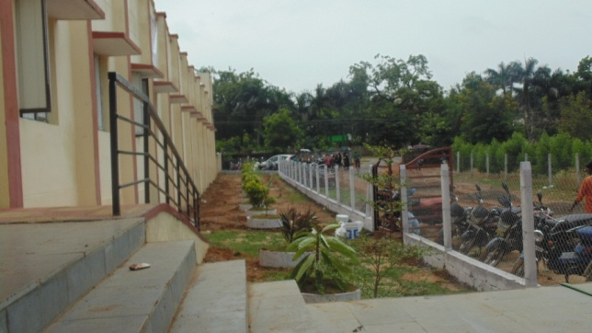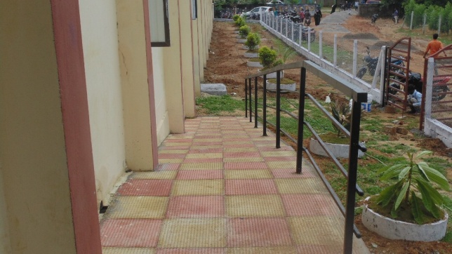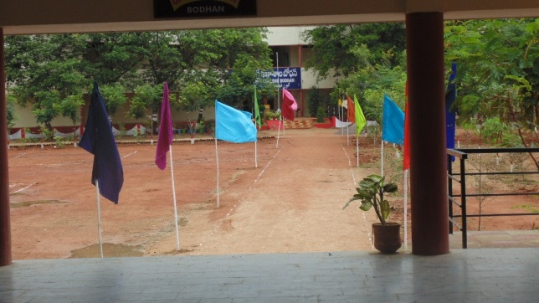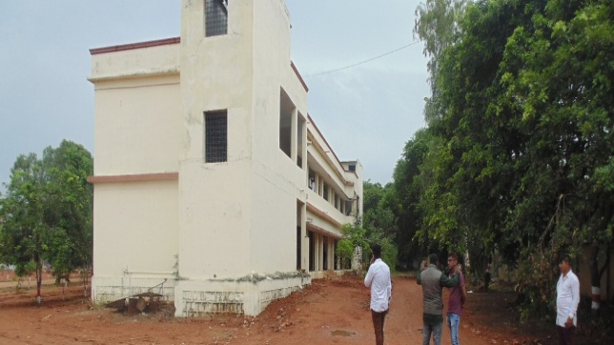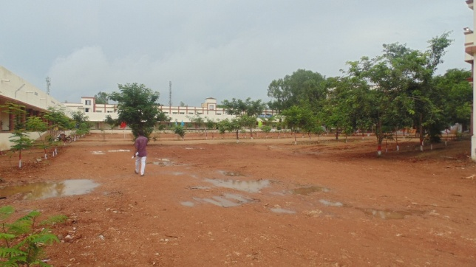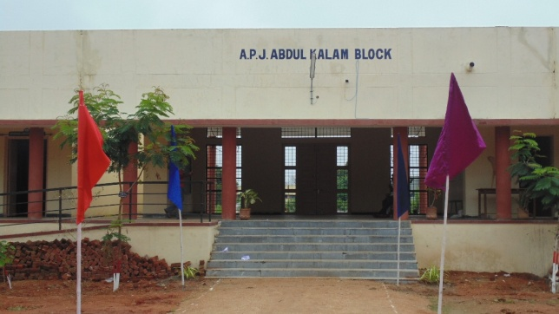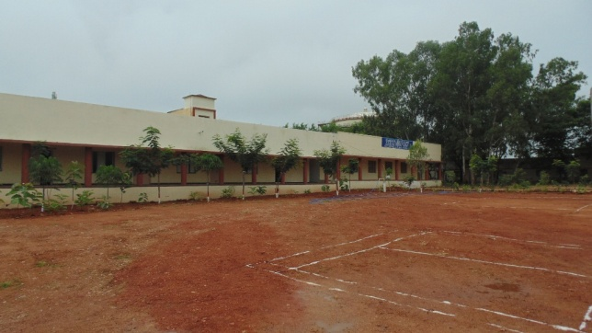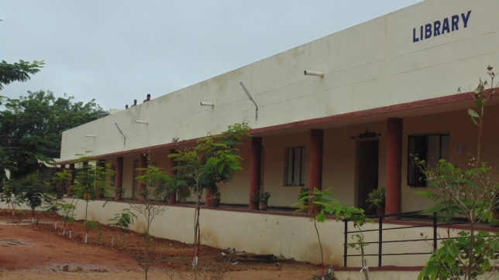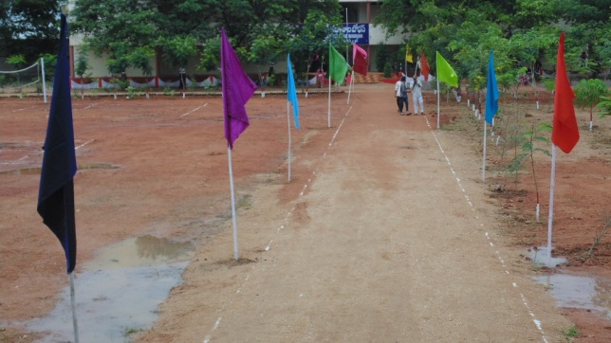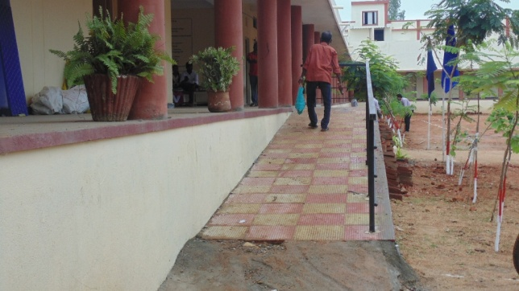

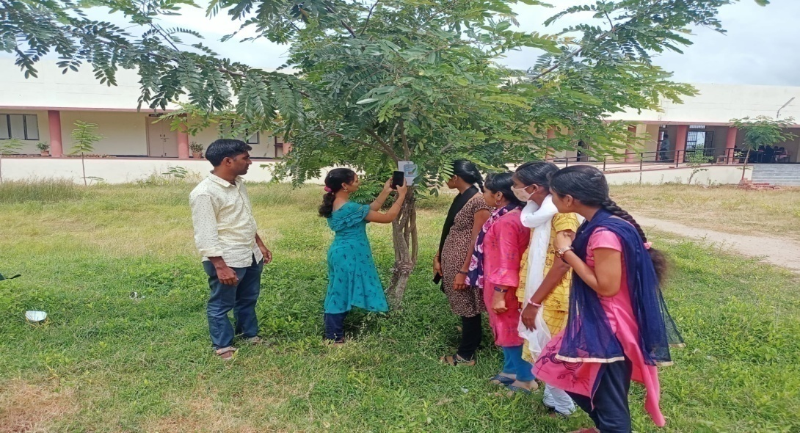
(A Student scanning Plant QR Code)

