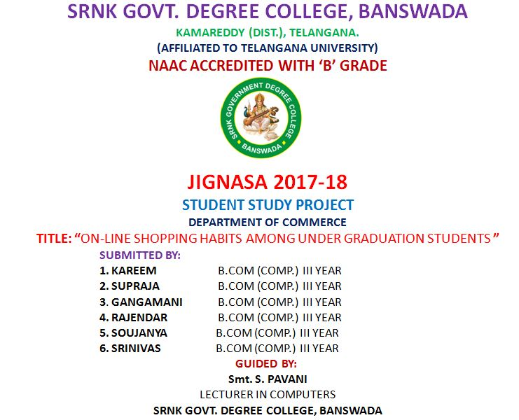

STUDY PROJECT

On

On-line Shopping Habits among Under Graduation Students

Introduction

Online shopping (sometimes known as e-tail from "electronic retail" or e-shopping) is a form of electronic commerce which allows consumers to directly buy goods or services from a seller over the Internet using a web browser. It is one of the offshoots of the ICT-cum-LPG. It is aimed at providing a hassle-free service to customers across the globe for purchasing a wide range of products, sitting at home. It saves the operational expenditure for the business men. Consequently, the prices of the products are cheaper. It creates great employment opportunities for software professionals for programming, operation, testing and upgrading. The known shopping platforms are Amazon, Flip cart, Snap deal, Alibaba, Dabang, Quicker etc.

Objectives

- To know the online shopping habits of the people

- To understand the tendency of online shopping among engineering students

- To see the kind of goods people generally purchase online

- To find out the problems faced by the customers online

Scope & Method of the Study

The study is limited to the random samples from the three years of Bachelor Degree of SRNK Govt.Degree College, Banswada, Kamareddy Dist. covering 100 students the rationale behind the selection of the Degree College is that commerce students are said to be accessing the online shopping more.

Area of Study: Profile

 | Name | : SRNK Govt.Degree College, Banswada
 | Mandal | : Banswada Mandal
 | District | : Kamareddy District
 | Category | : Government sector
 | Strength | : 1340
 | Distance from the College | : 3 kilo meters from Banswada town.

ANALYSIS

GENDER | NO. OF STUDENTS | % OF USERS | % OF NON- USERS
MALE | 54 | 81.4 | 18.5
FEMALE | 46 | 54.3 | 45.6

GENDER WISE PARTICULARS

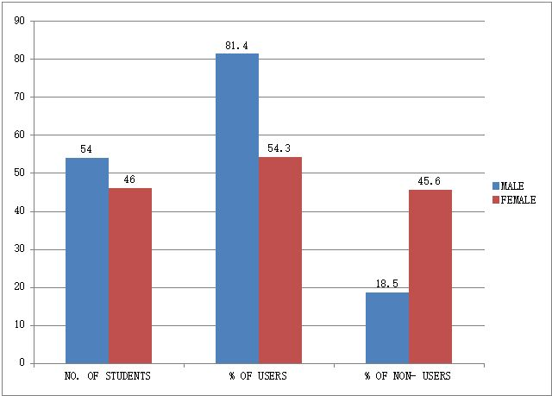

TYPE OF GOODS PURCHASED

TYPE OF GOODS | % OF USERS
Electronics | 67
Clothing | 42
Accessories | 42
Books | 14
Kitchenware | 4.6

TYPE OF GOODS PURCHASED

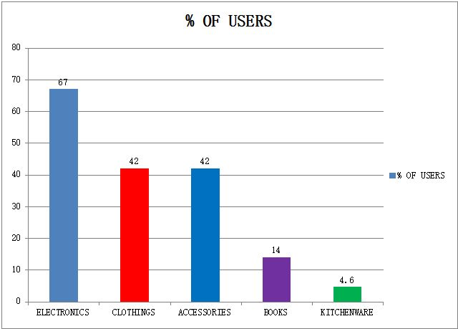

PROBLEMS FACED BY CUSTOMERS

TYPE OF PROBLEM | %
Delay In Delivery | 25
Cheap Quality Of Product | 28
Product Damage | 11
Non- Delivery | 12.5
Wrong Product | 14

PROBLEMS FACED BY CUSTOMERS

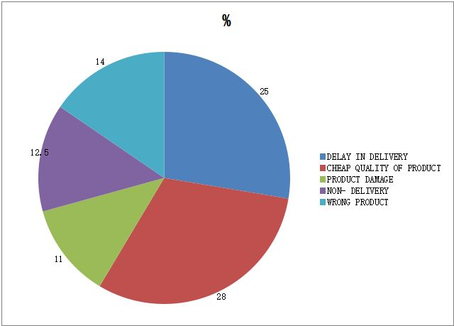

OPTIONS FOR PAYING THE BILL BY USER

TYPE OF PAYMENT | %
Cash On Delivery | 85.9
Credit Card | 10.9
Debit Card | 7.8
Net Banking | 3.1

OPTIONS FOR PAYING THE BILL BY USER

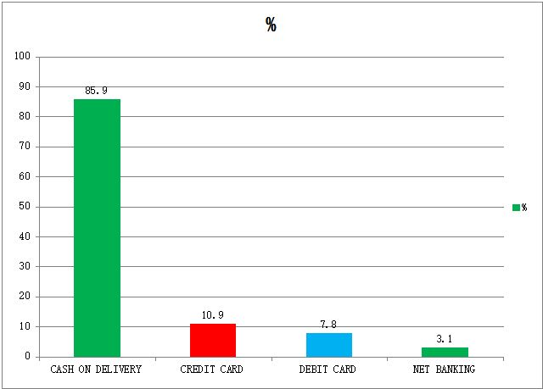

REASONS FOR NON- USING TOLD BY STUDENTS

REASON | %
Don’t Know About Online Shopping | 41.6
Risk Of Online Transactions | 54.6
Internet Illiteracy | 2.7

REASONS FOR NON- USING

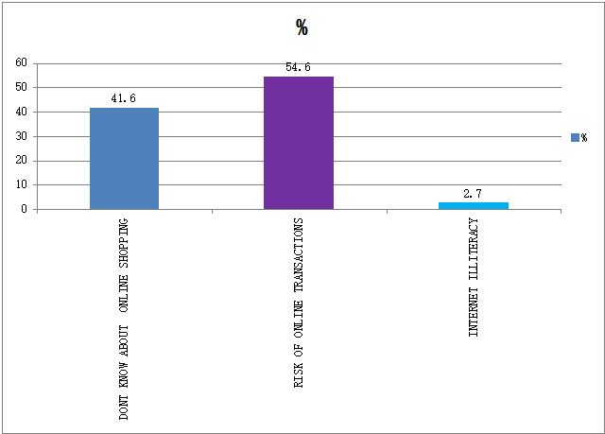

SITES USED BY USERS

NAME OF THE SITE | % OF USERS
FLIPKART | 86.6
SNAPDEAL | 34.3
AMAZON | 20.3
OLX.IN | 1.5
NAPTOL | 1.5
DABANG | 3.1
E-BAY | 4.8

% OF CUSTOMERS USING DIFFEENTSITES

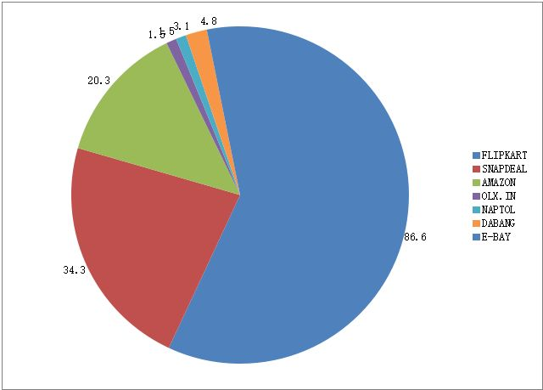
REPORT

The present study primarily reveals that men are using online shopping more than women. Electronic items are placed first among different items purchased through online. Clothing is next to electronics. This indicates that local electronic market is weak in meeting the customers' needs. Problems faced by the customers in online shopping are delay in delivery, product damage, wrong product, poor quality of products and even non- delivery too. Service providers must take care of the delivery system. Most of the customers opt for cash on delivery to pay the bill. This is a matter of reliability of service providers and also suspicion on online transactions like net banking. A large no. of non- users cited the risk in online transactions as the main reason for staying away from online shopping. Flip kart is the site which is used by more no. of users.

RECOMMENDATIONS

Service providers must take care of complete process from maintenance of website to delivery of product. They have to focus on creating faith among users that online transactions are completely reliable. It helps to achieve less cash society which is the main objective of RBIs current monitory policy.

***

