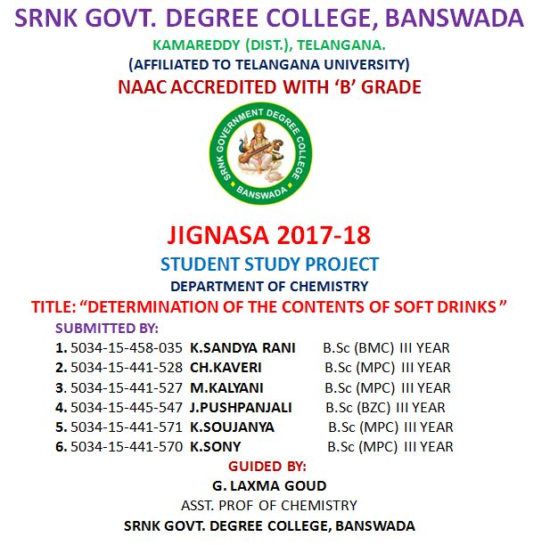

TITLE

Determination Of the Contents
Of
Soft Drinks

CONTENTS
I. RELEVANCE / STATEMENT OF THE PROBLEM
II. INTRODUCTION
III. AIMS AND OBJECTIVES
II. Theory
III. Apparatus
IV. Chemicals Required
V. Detection of pH
VI. Test for Carbon Dioxide
VII. Test for Glucose
VIII. Test for Phosphate
IX. Test for Alcohol
X. Test for Sucrose
XI. Result
XII. Conclusion

RELEVANCE / STATEMENT OF THE PROBLEM
In recent days, soft drink brands were put into various questions regarding their purity. News flashed that they contain harmful pesticide, which arouse many interest in knowing its contents because
we have been drinking them for years. We wanted to confirm that whether the charge imposed on these brands are true or not.
Another fact which inspired me to do this project is that we are in touch with qualitative analysis whose knowledge with other factors helped us to do so.

INTRODUCTION:
The era of cold drinks began in 1952 but the industrialization in India marked its beginning with launching of Limca and Goldspot by parley group of companies. Since, the beginning of cold drinks was
highly profitable and luring, many multinational companies launched their brands in India like Pepsi and Coke.
Now days, it is observed in general that majority of people viewed Sprite, Miranda, and Limca to give feeling of lightness, while Pepsi and Thumps Up to activate pulse and brain.

India is the world's fastest growing major economy and has already made it to the list of 10 biggest economies of the world. According to the International Monetary Fund (IMF), ‘India’ is the ‘ninth’ largest economy with a nominal GDP estimated at around US$ 2.04 trillion. With US$ 7.96 trillion PPP in terms of the Purchasing Power Parity (PPP), India is the third largest economy with US$ 7.96 trillion, and that is what makes it one of the biggest markets in the world. India is a major manufacturer and importer of soft drink beverages. The Indian soft drink industry is vast and is has been rapidly growing by the day. No matter what time of the year it is, soft drink beverages are consumed in great volume.
According to official reports, the volume of soft drinks consumed in India stood at a whopping 11,755 million litres in 2013. These numbers suggest that there was an increase of about 170 percent in the consumption of soft drinks in comparison to 2008. It is further expected that the sale of soft drinks may go up by an annual 19 percent till until 2018.
AIMS AND OBJECTIVES:

AIM:
Comparative study and qualitative analysis of different brands of soft drinks available in market.
OBJECTIVES:
1) To know the presence of harmful substances in various soft drinks.
2) creating awareness among people in rural area about the harmful effects of soft drinks.
THEORY
Cold drinks of different brands are composed of alcohol, carbohydrates, carbon dioxide, phosphate ions etc. These soft
drinks give feeling of warmth, lightness and have a tangy taste which is liked by everyone. Carbon dioxide is responsible for the formation of froth on shaking the bottle.
The carbon dioxide gas is dissolved in water to form carbonic acid. which is also responsible for the tangy taste. Carbohydrates are the naturally occurring organic compounds and are major source of
energy to our body. General formula of carbohydrates is CX (H2O)Y.
On the basis of their molecule size carbohydrates are classified as:-
Monosaccharide, Disaccharides and Polysaccharides. Glucose is a
monosaccharide with formula C6H12O6 .It occurs in Free State in the ripen grapes in bones and also in many sweet fruits. It is also present in human blood to the extent of about 0.1%. Sucrose is one of the most useful disaccharides in our daily life. It is widely distributed in nature in juices, seeds and also in flowers of many plants. The main source of sucrose is sugar cane juice which contain 15-20 % sucrose and sugar beet which has about 10-17 % sucrose. The molecular formula of sucrose is C12H22O11. It is produced by a mixture of glucose and fructose. It is non-reducing in nature whereas glucose is reducing. Cold drinks are a bit acidic in nature and their acidity can be measured by finding their pH value. The pH values also depend upon the acidic contents such as citric acid and phosphoric acid.
List of major and most popular soft drinks in India
1) Pepsi
2) Coca cola
3) Sprite
4) Thumbs up
5) Limca
6) Fanta

7) Mazaa

RESEARCH METHODOLOGY

SAMPLING, EXAMINATION.

APPARATUS
- Test Tube
- Test Tube Holder
- Test Tube Stand
- Stop Watch
- Beaker
- Burner
- pH Paper
- Tripod Stand
- China Dish
- Wire Gauge
- Water Bath

CHEMICALS REQUIRED
- Iodine Solution
- Potassium Iodine
- Sodium Hydroxide
- Fehling’s A & B Solution
- Lime Water
- Concentrated HNO3
- Benedict Solution
- Ammonium Molybdate

- DETECTION OF PH

EXPERIMENT
Small samples of cold drinks of different brands were taken in a test tube
and put on the pH paper. The change in the color of pH paper was noticed
and was compared with the standard pH scale.

OBSERVATION
SL.No | NAME OF THE DRINK | Colour change | pH value
1 | Coca cola | Pink | 2.5-3
2 | Sprite | Red | 3
3 | Limca | Pinkish | 4
4 | Fanta | Light orange | 3-4

INFERENCE
Soft drinks are generally acidic because of the presence of citric acid and phosphoric acid. pH values of cold drink of different brands are different due to the variation in amount of acidic contents.

- TEST FOR CARBON DIOXIDE

EXPERIMENT
As soon as the bottles were opened, one by one the sample was passed through lime water. The lime water turned milky.

OBSERVATON
SL.No | NAME OF THE DRINK | TIME TAKEN (SEC) | CONCLUSION
1 | Coca cola | 26.5 | CO2 is present
2 | Sprite | 21 | CO2 is present
3 | Limca | 35 | CO2 is present
4 | Fanta | 36 | CO2 is present

INFERENCE
All the soft drinks contain dissolved carbon dioxide in water. The carbon dioxide (CO₂) dissolves in water to form carbonic acid, which is responsible for its tangy taste.

CHEMICAL REACTION INVOLVED

Ca(OH)2(s) + CO2(g) -----------> CaCO3(s) + H2O(s)

- TEST FOR GLUCOSE

EXPERIMENT
Glucose is a reducing sugar acid. Its presence is detected by the following test:-

i. BENEDICTS’S REAGENT TEST:-
Small samples of cold drinks of different brands were taken in a test tube and a few drops of Benedict’s reagent were added. The test tube was heated for few seconds. Formation of reddish colour confirmed the presence of glucose in cold drinks.

OBSERVATION

SL.No | NAME OF THE DRINK | OBSERVATION | CONCLUSION
1 | Coca cola | REDDISH COLOUR  PRECIPITATE | GLUCOSE IS PRESENT
2 | Sprite | REDDISH COLOUR  PRECIPITATE | GLUCOSE IS PRESENT
3 | Limca | REDDISH COLOUR  PRECIPITATE | GLUCOSE IS PRESENT
4 | Fanta | REDDISH COLOUR  PRECIPITATE | GLUCOSE IS PRESENT

INFERENCE
All the samples gave positive test for glucose with Benedict’s reagent. Hence all the drinks contain glucose.

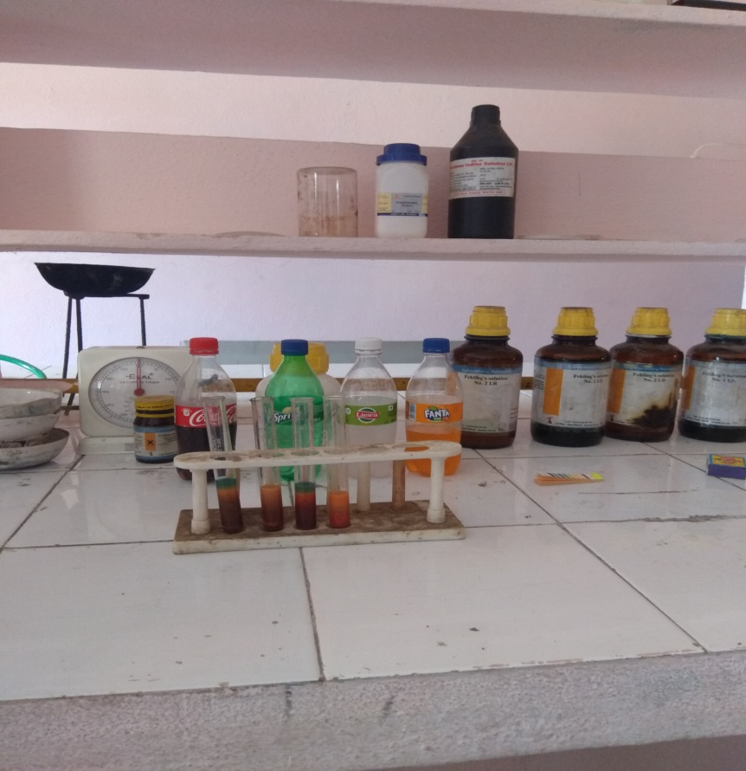

ii. FEHLING’S SOLUTION TEST :-
Small samples of cold drinks of different brands were taken in a test tube and a few drops of Fehling’s A solution and Fehling’s B solution was added in equal amount. The test tube was heated in a water bath for 10 minutes. Appearance of brown precipitate confirmed the presence of glucose in cold drinks.
OBSERVATION:

SL.No | NAME OF THE DRINK | OBSERVATION | CONCLUSION
1 | Coca cola | REDDISH BROWN  PRECIPITATE | GLUCOSE IS  PRESENT
2 | Sprite | REDDISH BROWN  PRECIPITATE | GLUCOSE IS  PRESENT
3 | Limca | REDDISH BROWN  PRECIPITATE | GLUCOSE IS  PRESENT
4 | Fanta | REDDISH BROWN  PRECIPITATE | GLUCOSE IS  PRESENT

INFERENCE
All the samples gave positive test for glucose with Fehling’s (A & B) solutions. Hence all the cold drinks contain glucose.
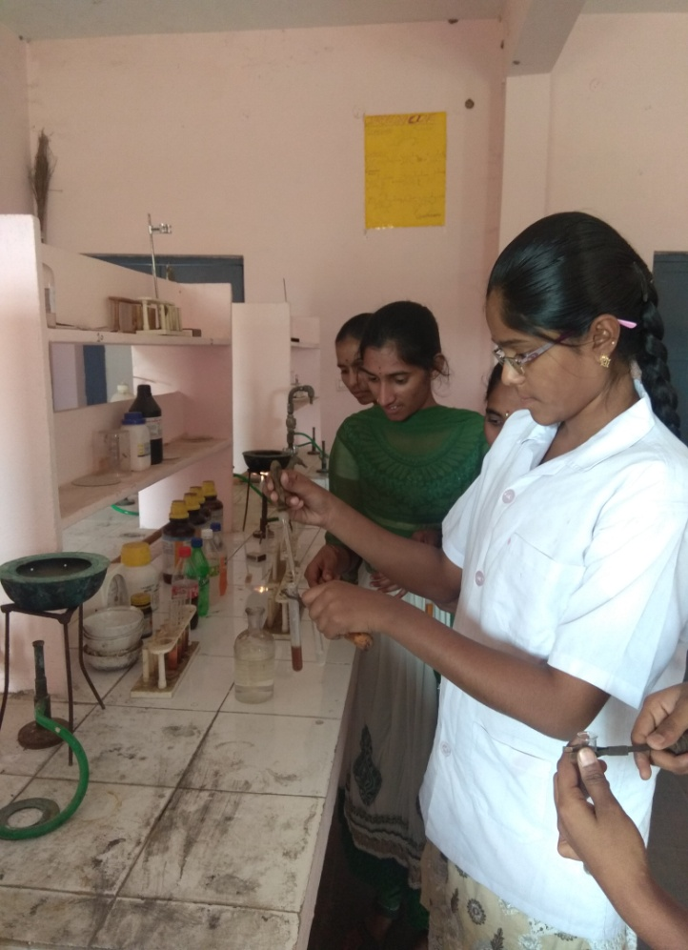

- TEST FOR PHOSPHATE

EXPERIMENT
Small samples of each brand of cold drinks were taken in separate test tubes and Ammonium Molybdate followed by concentrated Nitric Acid (HNO3) was added to it. The solution was heated. Appearance of canary-yellow precipitate confirmed the presence of phosphate ions in cold drinks.

OBSERVATON

SL.No | NAME OF THE DRINK | OBSERVATION | CONCLUSION
1 | Coca cola | CANARY-YELLOW  PRECIPITATE | PHOSPHATE IS  PRESENT
2 | Sprite | CANARY-YELLOW  PRECIPITATE | PHOSPHATE IS  PRESENT
3 | Limca | CANARY-YELLOW  PRECIPITATE | PHOSPHATE IS  PRESENT
4 | Fanta | CANARY-YELLOW  PRECIPITATE | PHOSPHATE IS  PRESENT

INFERENCE
All the soft drinks samples gave positive test for phosphate ions. Hence all the cold drinks contain phosphate.

CHEMICAL REACTION INVOLVED

NaHPO4 + 12(NH4)2MoO4 + 21HNO3 + 3H⁺---------> (NH4)3PO4.12MoO3 + 21HN4NO3 + 12H2O

- TEST FOR ALCOHOL

EXPERIMENT
Small samples of each brand of cold drinks were taken in separate test tubes and Iodine followed by Potassium Iodide and Sodium Hydroxide (NaOH) solution was added to each test tube. Then the test tubes were heated in hot water bath for 30 minutes. Appearance of yellow colored precipitate confirmed the presence of alcohol in cold drinks.

OBSERVATON

Sl.No | NAME OF THE DRINK | OBSERVATION | CONCLUSION
1 | Coca cola | YELLOW PRECIPITATE | ALCOHOL IS PRESENT
2 | Sprite | YELLOW PRECIPITATE | ALCOHOL IS PRESENT
3 | Limca | YELLOW PRECIPITATE | ALCOHOL IS PRESENT
4 | Fanta | YELLOW PRECIPITATE | ALCOHOL IS PRESENT

INFERENCE
All the cold drinks samples gave positive test for alcohol. Hence all the cold drinks contain glucose.

CHEMICAL REACTION INVOLVED

CH3CH2OH + 4I2 + 6NaOH-------->CHI3 + HCOONa + 5NaI + 5H2O

- TEST FOR SUCROSE

EXPERIMENT
5 ml samples of each brand of cold drinks were taken in separate china dishes and were heated very strongly until changes occur. Black colored residue left confirmed the presence of sucrose in cold drinks.

OBSERVATION:

Sl.No | NAME OF THE DRINK | OBSERVATION | CONCLUSION
1 | Coca cola | BLACK RESIDUE | SUCROSE IS  PRESENT
2 | Sprite | BLACK RESIDUE | SUCROSE IS  PRESENT
3 | Limca | BLACK RESIDUE | SUCROSE IS  PRESENT
4 | Fanta | BLACK RESIDUE | SUCROSE IS  PRESENT

INFERENCE
All the brands of cold drinks contain sucrose. But amount of sucrose varies in each brand of drink. It is not good for diabetic patients.

After conducting these tests in the laboratory, we decided to conduct these tests infront of Villagers which is near by our college.
with the collaboration with NSS UNIT-I of our college, we have conducted an awareness camp in that village about the harmful effects of soft drinks.
in addition to this, we have prepared questionnaire with this we got some Information from villagers regrading soft drinks. It was very useful in awareness camp.

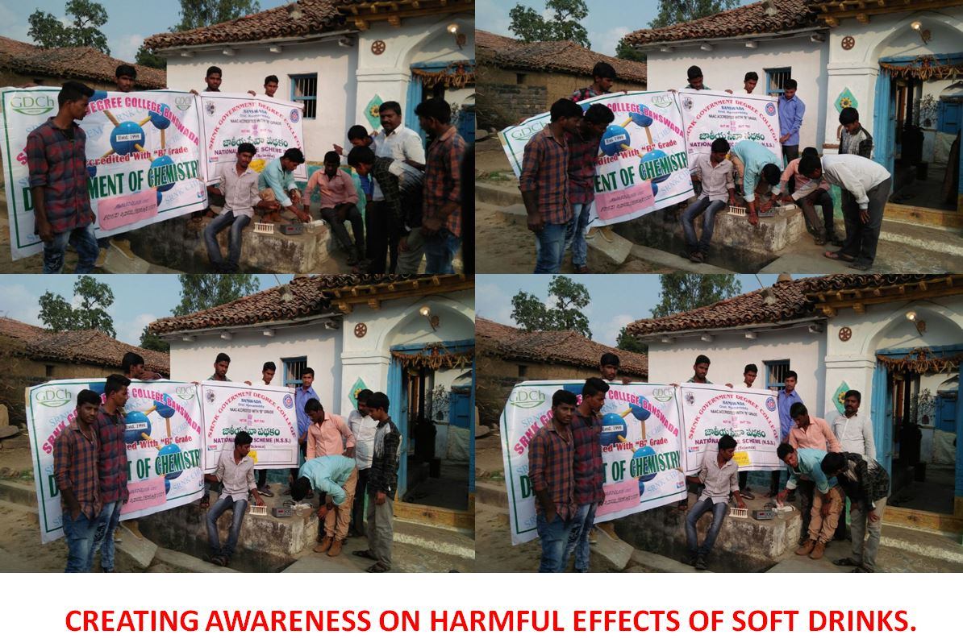

FINDINGS
After conducting several tests, it was concluded that the different brands of cold drinks namely:
1. Coca Cola
2. Sprite
3. Limca
4. Fanta
All contains glucose, alcohol, sucrose, phosphate and carbon dioxide. All cold drinks are acidic in nature.
CONCLUSION AND SUGGESTIONS:
1. Soft drinks are little more harmful than sugar solution. As they
contain sugar in large amount which cause problems in diabetes patients.
2. Soft drinks can cause weight gain as they interfere with the body’s natural ability to suppress hunger feeling.
3. Soft drinks have ability to dissolve the calcium so they are also harmful for our bones.
4. Soft drinks contain “phosphoric acid” which has a pH of 2.8. So they can dissolve a nail in about 4 days.
5. For transportation of soft drinks syrup the commercial truck must use the hazardous matter place cards reserved for highly conceive material.
6. Soft drinks have also ability to remove blood so they are very harmful to our body.

USES OF SOFT DRINKS
1. Cold drinks can be used as toilet cleaners.
2. They can remove rust spots from chrome car hampers.
3. They clean corrosion from car battery terminals.
4. Soft drinks are used as an excellent ‘detergent’ to remove grease from clothes.
5. They can looses a rusted bolt.

BIBLIOGRAPHY/REVIEW OF LITERATURE

- Practical organic chemistry by vogel
- Wikipedia
- Projects.icbse.com

