FACULTY PROFILE
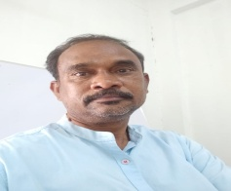
NAME: S.VENKAT KISHAN
MOBILE: 9440577533
Email : singaramvenkatkishan@gmail.com
Designation : Lecturer in Economics
Department: Economics
Academic Qualifications :
M.A Economics from Osmania University Hydrabad.
M.A History from Osmania University Hydrabad.
T.P.T from malayala swami T.P.Tcollege Prodduture Kadapa

Professional Experience:

Teaching:
- Worked as a degree college lecturer in Economics, Govt Degree collage, Armoor from 2002-2012.Nizamabad Dist.
- Worked as a degree Lecturer in Economics, MMDC Govt Degree College From 2012-2017 Shakker Nagar,Bodan, Nizamabad Dist
- Working as a Degree College Lecturer in Economics, Govt Degree College, From 2017 till Today Dharpally, Nizamabad Dist.

SEMINARS/COFERENCES/WORKSHOPS/ SYMPOSIUMS

Inter National Seminar;
Three day Inter national – e - work shop – Department of Economics Studdies and planning central university of Karnataka On “koutilya Artha Shastra” .
National seminars:
Attended Six –National seminars.

