FACULTY PROFILE

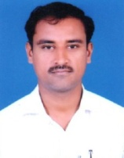

NAME: T SANJEEV KUMAR
MOBILE: 9618109535
Email : sanjeev9535@gmail.com
Designation : Lecturer in Zoology
Department: Zoology
Academic Qualifications :
M.Sc Zoology from Nizam College ,Osmania University.
B.Ed from Osmania University

Professional Experience:
Teaching:
- Worked as a Degree College Lecturer, Govt Degree College, Morhtad, Nizamabad Dist.
- Worked as a Degree College Lecturer, Govt Degree College, Armoor, Nizamabad Dist.
- Working as a lecturer in Zoology,Govt Degree College, Dharpally, Nizamabad Dist.

Administrative:
- Scholarship Incharge.

SEMINARS/COFERENCES/WORKSHOPS/ SYMPOSIUMS:
- Attended International webinar organised by “GURU GOVIND SINGH INRDAPRASTHA UNIVERSITY” New Delhi.
- Three national seminar attended.

