FACULTY PROFILE

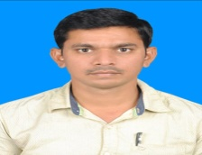
NAME: JADAV VASANTH
MOBILE: 8688561175
Email : jadav.vasanth108@gmail.com
Designation : Lecturer in English
Department: English
Academic Qualifications :
M.A English from Nizam College ,Osmania University.
B.Ed from University College of Education,TU

Professional Experience:
Teaching:
- Worked as a Degree College English Lecturer, Giriraj Govt Degree College, Nizamabad Dist.
- Working as a lecturer in English,Govt Degree College, Dharpally, Nizamabad Dist.
Research:
Topic : Project on Rewriting Dalit Aesthetics: A Study Of Contemporary Dalit
Writings With Reference To Sharn Kumar Limbale under the guidance of
Dr.C.MURLIKRISHNA.Professor and Head Dept. of English,Nizam college.

Publications;
- Migration and formation of Transnational identities In Amitav Ghosh`s Novels, ISSN2349-5189,June 2021.
- Diaspora,Identity and Cyberspaces in Indian Cinema, ISSN2349-5189, Nov 2020.

