**GOVERNMENT DEGREE & P. G. COLLEGE**

**FOR WOMEN**

**HUSSAINI ALAM, HYDERABAD – 500 002. A. P.**

**(Accredited with B+ Grade by NAAC)**

**Phone: 24522052**

**E-mail:** [**hussainialum.ejkc@gmail.com**](mailto:hussainialum.ejkc@gmail.com)

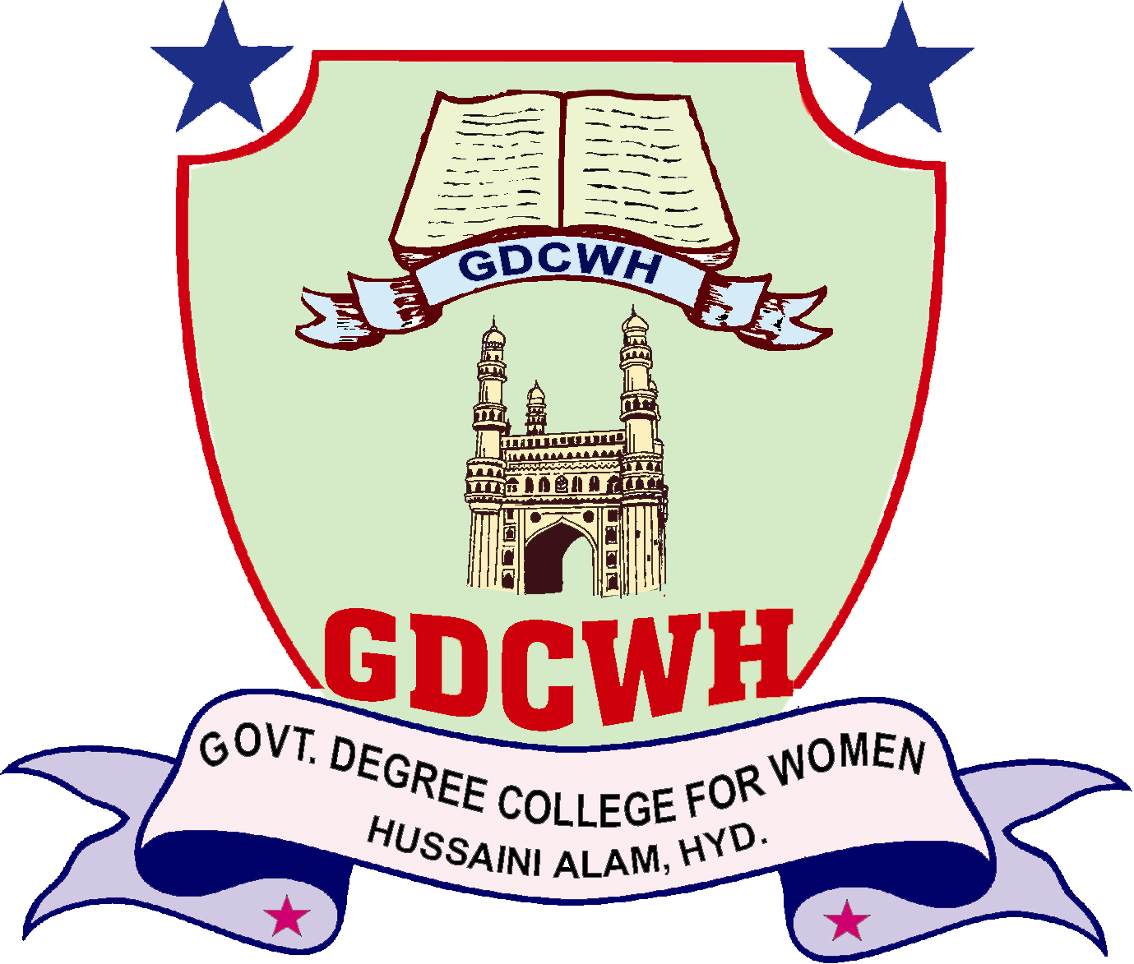

**GOVERNMENT DEGREE COLLEGE**

**FOR WOMEN**

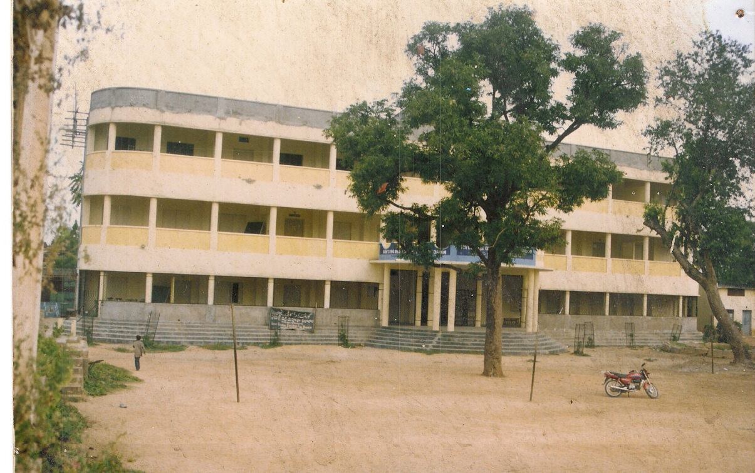

**HAND BOOK**

**2012 – 2013**

**STAFF LIST (Teaching)**

**P. Renuka (Principal)**

**Department of English**

1. Mrs Shahjahan Siddiqui

**Department of Urdu**

2. Dr. Safdar Askari

3. Mirza Mustafa Ali Baig

**Department of Hindi**

4. Mohammed Ismail

**Department of Arabic**

5. Mrs Sadia

.

**Department of Economics**

6. Mirza Fareed Ali Baig

**Department of Political Science**

7. Shabana Sultana (Contract)

8. Syeda Imrana (Guest)

**Department of History**

9. K.Padma(Contract)

10. Mrs. Juveria Fatima (Contract)

**Department of Commerce**

11. J Abraham

12. Aruna (Contract)

13. Lakshmi (Guest)

**Department of Chemistry**

14. Ms A Santoshi

15. Mrs. M Haripriya

**Department of Microbiology**

16. Mrs A Madhuri

17. Ms Habeeba Begum

**Department of Genetics**

18. Mrs. Mohammadi Begum (Contract)

19. Mrs.Rubeena Begum

**Department of Computer Applications**

20. Mrs R Vijaylakshmi

**Department of Games**

21. Mrs Emily Rose

**Department of Library**

22. Vacant

**ABOUT THE COLLEGE**

Government Degree College for women, Hussaini Alam, is a premier institution of higher education for women, and affiliated to the Osmania University. The College provides University Education to deserving candidates in a secular atmosphere and is committed to sure the economically weak, socially underprivileged

and the needy students.

            Government Degree college for women’s, Hussaini Alam was established in the year 1984 with a meagre strength of about 100 students. The college has made rapid progress in its growth. Initially the college started with B.A, and B.Com courses with Urdu and English as media of instruction. With the growing demand for new courses the college introduced Computer Applications in B.Com, and B.Sc was started in the year 1998 with Microbiology, Genetics and Chemistry as optional subjects. In the year 2000 the college was shifted in new building, now the college has sufficient accommodation for all the classes. Besides under graduate courses the college is also offering M.A. Urdu as post graduate level.

The college has good infrastructure with 17 class rooms, 4 laboratories and one conference hall and a library with 6,500 books, number of Journals, Magazines and News papers.

This college is the youngest Government College in the city and third Government College for women in the city and first Government College in the old city.

With this academic program and other activities the college is fulfilling its objective of “Empowerment of women” through knowledge.

In the year 2008 college has also been provided with Dr. Ambedkar Open University collaboration wherein courses are offered to students which help them in reconstructing their career

This year we have also installed a “Mineral Water Plant” taking further steps in the welfare activities taken up by college.

We are proud to announce that we are starting two new courses this year at UG and PG level viz. B.Sc (Botany Zoology, Chemistry) at UG level and M.Com at PG level.

**NAAC Accreditation:**

In recognition of its academic excellence the NAAC (National Academic Accreditation Council) an Autonomous institution of UGC has accredited the college with B+ Grade in the year 2005.

**Mission of the College:**

As the institution caters to the students coming from weaker sections our prime concern is to empower them by providing quality education:

* To develop confident and smart individuals who are ready to face the challenges of modern times.
* To strengthen this communications skills so as to make them successful in today job market.
* To instil the importance of moral values, working towards development of a complete personality.
* To involve students in the training of character and mould them to participate creatively as citizens.

**JAWAHAR KNOWLEDGE CENTRE (JKC):**

Jawahar Knowledge Centre (JKC) is a highly employment oriented programme of the State Government, specially those students who do not opt for higher studies after completion of their graduation. JKC helps the students in sharpening their skills in communication, reasoning and simple arithmetic which leads to the overall development of their personality so that they will be able to face the challenges of competitive job market.

**COURSES OFFERED, COMBINATION & SANCTIONED STRENGTH**

|  |  |  |  |  |
| --- | --- | --- | --- | --- |
| S. No. | Course Offered | Combination | Medium | Sanctioned Strength |
|  | B. A. (Regular) | History  Economics  Political Science | English | 60 |
|  | B. A. (Regular) | History  Political Science  Modern Language (Urdu) | Urdu | 60 |
|  | B. Com | General  (Regular) | English | 60 |
|  | B. Com.  (Restructured Course) | Computer Applications | English | 60 |
|  | B. Sc.  (Restructured Course) | Microbiology  Genetics  Chemistry | English | 60 |
|  | M. A. (Urdu)  (Self Financed Course) | P. G. | Urdu | 30 |
|  | M.Com | P.G | English | 30 |

**ADMISSION PROCEDURE:**

1. Application for admission should be in the prescribed form, which can be obtained from the college office during the college timings after notification.
2. Candidates who wish to be considered for admission into more than one course or group or medium should submit separate applications for each course groups or medium into which they seek admission. Mention of II & III choice in the same application will not be considered.
3. Application form duly filled in should be submitted in the college office between 1st June 2010 to 10th June 2010 only along with the Registration fee of Rs. 60/-
4. Applicants belonging to the scheduled castes or scheduled tribes or Backward Classes should specify their Caste, Sub-Caste and group in detail in the application form.
5. A latest passport size photograph should be affixed on the top right side of the front page of the application form.

**ELIGIBILITY CRITERIA FOR DEGREE COURSE**

1. Candidates seeking admission into I year B. A., B. Sc. B. Com. (General & Computer Applications) should have passed two year intermediate examination conducted by Board of Intermediate, A.P. or an examination of any other university /board, recognized at equivalent thereto.
2. (a) Admission to I year of the three years degree course will be made on the

basis of marks secured in one attempt.

(b) Candidate who have qualifying examination in parts (compartmentally will

also be considered for admission, but their cases will be considered only

when all candidate under category (a) are accommodated.

(c) Candidate seeking admission to B. Sc. I year course should obtain not less

than 40% marks in aggregate in the concerned science subject at the

qualifying Examination (35% in case of Scheduled caste and Scheduled

tribe)

1. 60% of B. Com. Seats are reserved for candidates who have passed the qualifying exam with commerce as one of the subject.
2. 50% of B. A. seats are reserved for candidates who have passed the qualifying examination with humanity.

**ENCLOSURES (XEROX COPIES)**

1. Migration certificate in case of candidate who pass the qualifying examination other than Board of Intermediate Examinations.
2. Transfer certificate from the college where last studied.
3. Pass certificate and memo of marks of the qualifying exam.
4. Bonafide certificate from the college where last studied.
5. Community certificate in case the applicant belong to Scheduled caste, Scheduled tribe, Backward class issued by a competent authority. (from M.R.O)
6. Certificate if any of special proficiency, extra curricular activities including sports, games, NCC, NSS,CULTURA; etc/
7. PHC, Ex servicemen – supporting evidence.

**SELECTION:**

1. All selections are strictly provisional and are subject to confirmation only after the interview by the Principal.
2. List of selected candidates will be notified on the College Notice Board as per the Osmania University admission scheduled.
3. Selected candidates must produce the ORIGINAL CERTIFICATES mentioned above for verification by the selection committee at the time of interview.
4. A candidate’s admission may be cancelled at any time during the course of her study if any discrepancy is found after admission regard to community, marks statements etc.

**A CANDIDATE PROVISIONALLY SELECTED FOR ADMISSION WILL FOREFEIT HER SEAT IF:**

1. The Original Documents and Certificates are not submitted at the time of admission.
2. The above Original Documents and Certificates are found defective.
3. She fails to pay the prescribed fee within the given time.

**RULES OF ADMISSION:**

The following rules of Osmania University will be followed at the time of admission into a particular course.

1. Candidates should fill in the application form in their own hand writing.
2. No transfer will be allowed from one group / medium to another after the admission has been finalized
3. Form with incomplete information will be rejected.
4. Admission of all classes will be strictly on the basis of merit and reservation.
5. No donation for admission is accepted.
6. Candidates are excepted to preserve the registration fee receipt and produce at the time of admission
7. The list of candidates selected for admission to various course will be displayed on the notice board of the college. No intimation will be sent individually. Candidate should periodically check with the college office about the likely dates of the display of list.
8. If a candidate fails to pay the fees within the stipulated time, she will not be considered for the subsequent list.
9. We do not any have any connection with Govt. Jr. College for girls, Hussaini Alam, Hyderabad.

**FEE PARTICULARS FOR B.A, B.Com, B.Sc I, II & III YEAR 2010-11**

|  |  |  |  |  |  |  |  |
| --- | --- | --- | --- | --- | --- | --- | --- |
| COURSE | COMBINATION & MEDIUM | I YEAR | | II YEAR | | III YEAR | |
|  |  | T.fee | Spl.fee | T.fee | Spl.fee | T.fee | Spl.fee |
| B. A | EPH  E/M | 505 | 439 | 505 | 284 | 505 | 284 |
| B. A | HPML  U/M | 505 | 439 | 505 | 284 | 505 | 284 |
| B. Com | General  E/M | 505 | 534 | 505 | 379 | 505 | 379 |
| B. Com | Computers  E/M | 505 | 3911 | 505 | 3746 | 505 | 3746 |
| B. Sc | M.G.C.  E/M | 505 | 4021 | 505 | 3824 | 505 | 3824 |

**GENERAL RULES**

1. When a student joins in the college, it is assumed that she accepts and obliges to abide by the rules in force.
2. A student is expected to behave decently with all members of the teaching staff and all supporting staff.
3. Students should refrain from loitering in the corridors or standing in the verandahs during workings hours. The leisure periods may be utilized in the Library or reading room.
4. Every student should carry her Identity Card with her daily.
5. The name of the student absent to the college for more than fifteen days continuously without intimation will be removed from the rolls.
6. Students who are granted admission will be required to pay the entire college fee of the year in advance. Otherwise, they will not be allowed to attend the classes and their examination form will not be forwarded to the University & they will not be allowed to write the Annual Examination.
7. Every student must put in a minimum of 75% attendance to be eligible for scholarship or bus pass concession.
8. Enrollment of III and II year students in the month of june by paying Spl Fee.
9. All III year students has to do one certificate course(MLT or MS-Office or Tally) and should join in the Tourism STP (Short term Programme) by paying nominal fee i.e. 300/- for certificate course & 200 for Short Term Programme
10. All I & II year students has to complete two certificate course(MLT or MS-Office or Tally) and should join in the Tourism STP (Short term Programme) and communicative skills by paying nominal fee i.e. 300/- & 200/- for certificate courses

**COLLEGE ACTIVITIES**

**A) Tests and Examinations**

There will be a minimum of 5 tests in every subject in a year and apart from this there will be a Pre – final Examination in the month of February / March, on the model of University Examination. Attendance for these tests and pre – final examination is compulsory. The performance in these examination will be taken into consideration for the award of prizes and scholarships.

**B) Promotion in Annual Examination:**

1. A student who has completed regular course of study in the first year is eligible for promotion to the second year with a backlog not exceeding 50% (i.e. she must pass 3 out of 5) of 3 papers.
2. A student who has completed the regular course of study in the first year and second year with a backlog of four papers in the first year and second year put together is eligible for promotion to the final year.

**IMPROVEMENT:**

A student is eligible to appear for improvement provided:

1. She has passed in all the papers in one attempt only.
2. If she has passed the examination in March, then she should take Improvement only in the immediate Supplementary Examination.

**C) ATTENDANCE:**

1. Every student is required to attend classroom subject lectures and Practical work punctually and regularly.
2. Every student must have at least 75% attendance in every subject of the course to secure eligibility to appear for the University Examination.
3. No student shall absent herself from the college without submitting application for leave of absence. It should be endorsed by the parents /Guardians and handed over to the class lecturer. If the leave of absence is for more than five days a certificate from a medical Practitioner is necessary.

**DISCIPLINE:**

There is Discipline and Attendance Committee comprising a team of lecturers to ensure the strict observance of rules.

1. Students are required to attend all the classes including practical classes regularly and punctually. Also, they should maintain discipline in the classroom as well as in the college campus.
2. Students misbehaving in the classroom and in the college campus will be severely punished.
3. Students are required to abide by the instruction issued by the principal.
4. The principal will communicate with the parents /Guardians of those students, whose behaviour and progress in studies is not satisfactory.
5. Students are required to observe order at all times in the college and should not make noise while moving from one classroom to another.
6. Spitting on the walls and floors and throwing of waste papers within the college premises is forbidden.
7. Student are prohibited from organizing any meeting or entertainment in the college and collecting money for any purpose without obtaining prior permission of the principal
8. The principal reserves the right to suspend or dismiss any student who is found guilty of serious indiscipline.

**EXTRA CURRICULAR ACTIVIEIES:**

The college is concerned not merely with the academic progress of the students but it endeavours to help each student to realize their maximum potential and to acquire self – discipline, excellent morals and a deeper sense of personal and social responsibility. This college considers all extra – curricular activities, an integral and important part of the college education.

1. **SPORTS & GAMES:**

The college is equipped with full facilities for physical Education like indoor and outdoor games material, sufficient ground etc. Our student has participated in Inter– collegiate, Inter University and National level Sports and have been winning medals and Shields since many years.

**GYM:** There is a well equipped gymnasium for the improvement of physical health of the students and to ensure their physical fitness.

1. **NATIONAL SERVICE SCHEME (NSS):**

The college has 4 units of N.S.S. since 1998 about 30 students are involved in the N.S.S. activities under the guidance of 4 trained program Officers. The N.S.S. Volunteers are actively involved in programs like Adult Literacy, Blood Donation Camps, Tree plantation, Campus Cleaning, Health Check –up Camp, AIDS Awareness camp etc.

1. **LITERARY AND CULTURAL ACTIVITIES:**

The college conducts different competitions under the auspices of the literary and Cultural Committees. Essay writing, Elocution, Creative writing and Quiz. Competitions. Dramas, One –act plays. Songs competitions are held every year .Our students have won many prizes in these competitions at Inter collegiate, Inter University and state level.

1. **COLLEGE LIBRARY:**

The college has a full – fledged library with about 7000 books on different subjects and different languages. All he books are computerized and automation is under process. There is a separate reading room with magazines, dailies and study material, which is kept open beyond college hours also.

1. **COMPUTER LABS:**

The college has two air- conditioned Laboratories, where 45 P.C. sets are available efficient Instructors and teachers. Internet facility is available in all the departments.

1. **CAREER GUIDANCE /STUDENTS REDRESAL CELL:**

This special Committee consisting of senior teachers is constituted at the college level for the benefit of the students, to solve their problems. The committee counsels students for their bright future and placements.

**FEE CONCESSION:**

Students belonging to the scheduled Castes, Scheduled Tribes and Adi- Andhra Christians, Vimukta Jatis and Semi Nomadic Tribes are given full fee concession on production of a certificate of Caste and Income in the prescribed form, issued the M.R.O.

All students who enjoy fee concessions should pay the special fees in full.

**ADVISORY COMMITTEES FOR THE YEAR**

**2011-2012**

1. **STUDENTS UNION COMMITTEE**

Dr. Safdar Askari - Convenor

Mrs. Shah Jahan Siddiqui - Member

Mrs. Juveria Fatima - Member

Mrs. M.Haripriya - Member

1. **EXAMINATION COMMITTEE (ALL EXAMS)**

Mr. Fareed Ali Baig - Convenor

Ms. Shabana Sultana - Member

Mrs.Mohammadi Begum - Member

Mrs.K. Padma - Member

1. **JAWAHAR KNOWLEDGE CENTER COMMITTEE**

Dr.Safdar Askari - Convenor

Mrs. Shah Jahan Siddiqui - Member

Mrs. Mohammadi Begum - Member

JKC Mentor Mrs.K. Padma - Member

1. **INTERNAL QUALITY ASSURANCE CELL & NAAC COMMITTEE**

Mr. Fareed Ali Baig - Convenor

Dr. Safdar Askari - Member

Mrs.K. Padma - Member

Mr. Mirza Mustafa Ali Baig - Member

Mrs. Shahajahan Siddiqui - Member

Mrs. Mohammadi Begum - Member

Ms. Shabana Sultana - Member

1. **MANA T.V. COMMITTEE**

Mrs Mohammedi Begum - Convener

Ms. Shabana Sultana - Member

Mrs.Juveria Fatima - Member

Mrs.Shah Jahan Siddiqui - Member

1. **U.G.C. COMMITTEE**

Dr. Safdar Askari - Convenor

Mr. Fareed Ali Baig - Member

Mrs.Shahjahan Siddiqui - Member

Mr. Mirza Mustafa Ali Baig - Member

1. **LITERARY COMMITTEE**

Mrs. Shahjahan Siddiqui - Convenor

Mrs.K. Padma - Member

Ms. Shabana Sultana - Member

1. **CULTURAL COMMITTEE**

Mrs. Shahjahan Siddiqui - Convenor

Ms. Shabana Sultana - Member

Mrs. Juveria Fatima - Member

Mrs. K. Madhavi - Member

Mrs. Mohammadi Begum - Member

1. **IGNO COMMITTEE**

Mr. Fareed Ali Baig - Convenor

Dr.Safdar Askari - Member

Mrs. K. Madhavi - Member

Ms. Shabana Sultana - Member

1. **TIME TABLE COMMITTEE**

Mr. Fareed Ali Baig - Convenor

Mrs. Shahjahan Siddiqui - Member

Mrs.K. Padma - Member

Mrs.Mohammadi Begum - Member

Ms. Shabana Sultana - Member

1. **MAGAZINE & CALENDER COMMITTEE**

Mrs. Shahjahan Siddiqui - Convenor

Mr. Mirza Mustafa Ali Baig - Member

Mrs. Mohammadi Begum - Member

Mrs.K.Padma - Member

1. **N.S.S. COMMITTEE**

Dr. Safdar Askari - Convenor

Mrs. Mohammadi Begum - Member

Mrs. Juveria Fatima - Member

Mrs.M.Haripriya - Member

1. **CAREER GUIDANCE CELL**

Mrs. Shahjahan Siddiqui - Convenor

Mr. Mirza Fareed Ali Baig - Member

Mrs. Juveria Fatima - Member

Mrs. Mohammadi Begum - Member

Mrs.K.Padma - Member

1. **CENTRAL PURCHASE COMMITTEE**

Mr. Fareed Ali Baig - Convenor

Dr.Safdar Askari - Member

Mr.Mustafa Ali Baig - Member

1. **RESEARCH COMMITTEE**

Dr. Safdar Askari - Convenor

Mr. Fareed Ali Baig - Member

Mr. Mirza Mustafa Ali Baig - Member

Mrs. Shahjahan Siddiqui - Member

1. **CONSUMER CLUB**

Mr. Fareed Ali Baig - Convenor

Ms. Shabana Sultana - Member

Mrs. Shajahan Siddiqui - Member

Mrs. Laxmi - Member

1. **LIBRARY COMMITTEE**

Mr.Mirza Mustafa Ali Baig - Convenor

Mrs. Juveria Fatima - Member

Mrs.Mohammadi Begum - Member

Mrs. Shahjahan Siddiqui - Member

Mrs.K.Padma - Member

1. **YOUTH RED CROSS WING**

Dr. Safdar Askari - Convenor

Mr. Mirza Mustafa Ali Baig - Member

Mrs. K Padma - Member

Ms. Shabana Sultana - Member

1. **GAMES & SPORTS COMMITTEE**

Mrs. Shajahan Siddiqui - Convenor

Mrs. Juveria Fatima - Member

Mrs. Mohammadi Begum - Member

1. **SCHOLOARSHIP COMMITTEE**

Mr. Mirza Mustafa Ali Baig - Convenor

Mrs K. Padma - Member

Mrs. Mohammadi Begum - Member

Mrs. Juveria Fatima - Member

Jyotsana - Member

Mr.Mohd Nazimuddin Irfan - Member

Miss.Nousheena Farheen - Member

1. **FURNITURE & ELECTRICITY COMMITTEE (MAINTENANCE)**

Mr. Mirza Fareed Ali Baig - Convenor

Dr.Safdar Askari - Member

Mr.Mirza Mustafa Ali Baig - Member

1. **BUILDING COMMITTEE**

Mr. Mirza Fareed Ali Baig - Convenor

Dr.Safdar Askari - Member

Mr.Mirza Mustafa Ali Baig - Member

1. **INCOME TAX SCRUTINY COMMITTEE**

Mr. Mirza Fareed Ali Baig - Convenor

Miss Ruheena - Member

Mrs. Laxmi - Member

1. **AUDIO VISUAL COMMITTEE**

Mr.Mirza Mustafa Ali Baig - Convenor

Mrs.K.Padma - Member

Mr. Mirza Fareed Ali Baig - Member

Mrs. Shahjahan Siddiqui - Member

1. **CENTRAL ATTENDANCE / MARKS COMMITTEE**

Mr.Fareed Ali Baig - Convenor (For Arts)

Mrs. Juveria Fatima - Member (For Arts)

Mrs.Mohammadi Begum - Member (For Science)

1. **SPECIAL FEE COMMITTEE**

Mr. Fareed Ali Baig - Convenor

Mr. Mirza Mustafa Ali Baig - Member

Ms. Shabana Sultana - Member

Dr. Safdar Askari - Member

1. **P.G.COMMITTEE**

Dr. Safdar Askari - Convenor

Mr.Mirza Mustafa Ali Baig - Member

1. **DISCIPLINE COMMITTEE**

Dr. Safdar Askari - Convenor

Mrs. Mohammadi Begum - Member

Ms. Shabana Sultana - Member

Mrs.M.Hari Priya - Member

Mrs.K.Padma - Member

1. **GRIEVANCE AND REDRESSAL CELL**

Dr. Safdar Askari - Convenor

Mr. Mirza Mustafa Ali Baig - Member

Mr. Fareed Ali Baig - Member

1. **ECO & NATURE CLUB**

Mr. Fareed Ali Baig - Convenor

Mrs. Juveria Fatima - Member

Mrs. Mohammadi Begum - Member

Mrs. Shahjahan Siddiqui - Member

Ms. Shabana Sultana - Member

1. **ALUMINI COMMITTEE**

Mr. Mirza Fareed Ali Baig - Convenor

Dr. Safdar Askari - Member

Mr. Mirza Mustafa Ali Baig - Member

Ms. Shabana Sultana - Member

Mrs.Mohammadi Begum - Member

1. **PARENT –TEACHER COMMITTEE**

Mr.Mirza Mustafa Ali Baig - Convenor

Mr. Fareed Ali Baig - Member

Dr.Safdar Askari - Member

Ms. Shabana Sultana - Member

1. **HEALTH CENTER**

Dr. Safdar Askari - Convenor

Mrs K.Padma - Member

Mrs. Juveria Fatima - Member

Mrs. Shahjahan Siddiqui - Member

1. **ATTENDANCE & BUS PASSES**

Mr.Fareed Ali Baig - COMMERCE – General

Mrs Shahjahan Siddiqui - COMMERCE – Computer

Mrs.Mohmmadi Begum - SCIENCE

Mr.Mirza Mustafa Ali Baig - ARTS – Urdu Medium –

Dr.Safdar Askari - ARTS – English Medium –

Dr.Safdar Askari - P.G.

1. COMMITTEE FOR PREVENTION OF GENDER BASESD – HARASSMENT AND DISCRIMINATION

Dr. Safdar Askari - Convenor

Mr. Fareed Ali Baig - Member

Mrs. Mohammadi Begum - Member

Ms. Shabana Sultana - Member

Mrs K.Padma - Member

1. **COLLEGE DEVELOPMENT & PLANNING COMMITTEE**

Mr. Mirza Fareed Ali Baig - Convenor

Mr. Mirza Mustafa Ali Baig - Member

Mrs.M.Haripriya - Member

Mrs. Mohammadi Begum - Member

**STUDENTS CHARTER**

|  |  |  |  |
| --- | --- | --- | --- |
| Sl. No. | Nature of Service | Service delivery standard Time limit | Contract Person |
|  | Admissions:  a) Admission procedure and  time frame for admissions | As per the guidelines of University concerned.  3 days | Admissions incharge  Name: Mr.Fareed Ali Baig  Academic Co- ordinator |
|  | Facilities and Fee :   * 1. The courses, infrastructural facilities, faculty position, counseling and fee structure   2. Grievance redressal | As given in the prospectus  7 Days | Academic Co- ordinator |
|  | Academic Programmers:   1. No. of working days and No. of teaching hours (Theory and Practical) taken up for each subject. | As given in the prospectus | Department incharge |
|  | Extra Curricular Activities   1. Games and Sports facilities 2. NSS 3. Literary and cultural activities 4. Career guidance Programs 5. Guest lecturers / Extension lecturers 6. Grievance redressal | As given in the prospectus  2 days | Lecturers incharge   * 1. Incharge of the Department   2. Convener   3. Shahjahna SiddiquiConvenor   4. Dr.Safdar Askari Convenor   5. Convenor   6. Dr. Safdar Askari |
|  | Scholarships   1. Issue of Cheques 2. Grievance redressal | 2 – Days  Within 7 days after receipt of the amount from the treasury  3 – Days | Name: Mr. Mohd Nazimuddin Irfan  Junior Assistant  Mrs. Mirza Mustafa Ali Baig  Lecturer in Urdu |
|  | 1. Issue of certificates for regular students (as per rules and on submission of application in proper form) 2. Transfer Certificate 3. Bonafide and Conduct Certificate 4. Migration Certificates   (if issued at the college level)   1. Grievance redressal | 3 – Days | Name: Smt. A. S. Deepakala  Junior Assistant (Deputation)  Dr. Safdar Askari  Reader in Urdu |

**WHOM TO APPROACH:**

Principal shall be contacted when the grievance is not redressed with in the stipulated time by the first level contact person concerned mentioned in the table above.

**PUBLIC PARTICIPATION:**

It is ensured through College Planning and Development Council (CPDC) and parent teachers association meetings at least twice in a year of the college.

**HELP LINE:**

Individual staff members, In charge of the Departments and the principal can be approached by students/parents for any help.

**WHAT WE EXPECT FROM YOU:**

**STUDENTS:**

* Come regularly and punctually to the college.
* Attend all classes with out exception.
* Be sincere and honest in all activities/dealings.
* Participate in curricular/Extra curricular with zeal and enthusiasm.
* Appear for all monthly / Quarterly / Half-yearly/Pre-final examinations compulsory.
* Best on personal interest in maintenance and use of infra structural facilities.
* Be courteous and polite to all.
* Use proper methods while seeking grievance redressal.

**PARENTS:**

* Ensure and check the regular attendance of their words.
* Attend all parent-teacher meetings compulsorily.
* Actively participate in developmental activities of the college.
* Give immediate response to progress reports / letters.
* Above all identify yourselves with the institution and extend active cooperation / guidance for the development of the college.

**LIST OF THE COUNSELLORS 2011-2012**

|  |  |  |
| --- | --- | --- |
| Class | Year | Name of the Lecturer |
| B.Com (Gen) E/M | III Year | Mr Fareed Ali Baig  Ms Shabana Sultana |
| B.Com (Gen) E/M | II Year | Rubeena |
| B.Com (Gen) E/M | II Year | Mr N.Tirupathi |
| B.Com (Gen) E/M | I Year | Mrs. P.Laxmi |
| B.Com (Com) E/M | III Year | Jyotsona |
| B.Com (Com) E/M | II Year | PTC Commerce |
| B.Com (Com) E/M | I Year | M.Hari Priya |
| B.Sc (MGC) E/M | III Year | Mrs.Mohammedi Begum |
| B.Sc (MGC) E/M | II Year | Ms.Habeeba Fatima |
| B.Sc (MGC) E/M | I Year | Mrs.Madhavi Konda |
| B.A (HPML) U/M | III Year | Dr.Safdar Askari |
| B.A (HPML) U/M | II Year | Mrs. Juveria Fatima |
| B.A (HPML) U/M | I Year | Ms.Shahjahan Siddiqui |
| B.A (EHP) E/M | III Year | Mr.Mirza Mustafa Ali Baig |
| B.A (EHP) E/M | II Year | Mrs K. Padma |
| B.A (EHP) E/M | I Year | Rubeena |

**STAFF LIST (Non – Teaching)**

1. Vacant Senior Assistant
2. Mr. Mohd Nazimuddin Irfan Junior Assistant
3. Mrs.Deepekala Junior Assistant (Deputation)
4. Mr. D. Raja Narendar Record Assistant
5. Mohammed Arif Office Subordinate
6. Giri Babu Office Subordinate
7. V. Ramesh Kumar Lab Attender (Deputation)
8. Sri. Bhikshapathi Lab Attender (Deputation)
9. Mr. Satyanarayana Office Subordinate
10. Mr. Mohammed Tabrez Khan Allwyn Employee.
11. Mrs. Kamalamma Sweeper
12. Mrs. Noorjahan Water Carrier
13. Mrs. Santra Bai Scavenger
14. Vacant Watchman

|  |  |  |  |  |  |
| --- | --- | --- | --- | --- | --- |
| **INSTITUTIONAL CURRICULAM PLAN ACADEMIC YEAR 2010 – 2011** | | | | | |
| S. No. | MONTH | WEEK | TENTATIVE DATE (S) | ACTIVITY | LECTURER / STAFF IN CHARGE |
|  | May | 2nd | 10-05-2010 | Sale of applications starts | Mrs. Deepakala  Junior Assistant |
|  | June | 2nd | 07-06-2010  07-06-2010  08-06-2010  10-06-2010 | College reopens – General Staff Meeting  II & III yr Classes Commences  CPDC Meeting  Last date for registration of applications | Principal  -  Principal  Mrs. Deepakala |
|  |  | 3rd | 15-06-2010  18-06-2010  19-06-2010 | Announcement of 1st List  Staff Council Meeting  Announcement of Curricular Plans to students | All Admission Committee Convenors  Principal  All Lecturers |
|  |  | 4th | 25-06-2010 | Announcement of 2nd List | All Admission Committee Convenors |
|  | July | 1st | 03-07-2010  05-07-2010  06-07-2010 | Staff Council Meeting  1st year Classes Commences  JKC Committee Meeting | Principal  Concerned Staff member  Principal |
|  |  | 2nd | 12-07-2010  13-07-2010  15-07-2010 | One – day Orientation Programme for Ist Years  Extension Lecture in Commerce  Inter Collegiate  DRC Seminar for Lecturers  Training programme for teachers one day seminar for teachers Topic: Quality teaching in Higher Education | Principal & All I/C Department  Mr. V. L. Narayana Rao  I/c Commerce Dept.  DRC Activity |
|  |  | 3rd | 23-07-2010  20-07-2010  23-07-2010 | Workshop on “Self Employment Skills”  Formation of Students Union  CPDC – Meeting | Commerce Department  Dr. Safdar Askari  Student Advisory Committee  Principal |
|  |  | 4th | 24-07-2010  26-07-2010  27-07-2010  28-07-2010 | Meeting of I/C Science Depts.  Meeting of Arts Depts.  Fresher’s Day  Meeting with commerce Dept. | Principal  Principal  Dr. Safdar Askari  Student Union In-charge Convenor  Principal |
|  | August | 1st | 02-08-2010  05-08-2010  06-08-2010  07-08-2010 | Inter disciplinary Quiz competition in Science  ‘Friendship Day’  Student seminar on friendship  Field Visit by Microbiology Students  Staff Council Meeting | Department of Genetics  Student Union  Department of Microbiology  Principal |
|  |  | 2nd | 12-08-2010  13-08-2010  15-08-2010 | Literary Competitions to students in view of 63 Independence Day  Blood Donation Camp  Independence Day Celebrations | Dr. Safdar Askari  Dr. Safdar Askari  N.S.S  Student advisory Committee |
|  |  | 3rd | 21-08-2010  23-08-2010 | JKC Committee Meeting  Inter disciplinary Quiz Competition (B. A. Students) | Principal  Department of History |
|  |  | 4th | 27-08-2010  30-08-2010  31-08-2010 | CPDC Meeting  Extension Lecturer in Economics  Last date of filling up of admissions | Principal  Department of Economics |
|  | September | 1st | 01-09-2010  03-09-2010  04-09-2010  06-09-2010 | a) Staff Council Meeting  b) Field visit by Genetics Students  Extension Lecture in Chemistry  Extension Lecture in English  Teacher’s Day Celebrations | Principal  Department of Genetics  Department of Chemistry  Department of English  Dr. Safdar Askari  Student Advisory Committee, Convenor |
|  |  | 2nd | 08-09-2010  10-09-2010  13-09-2010  14-09-2010  15-09-2010 & 16-09-2010 | 1. “Literacy Day”   JKC Meeting  CPDC Meeting   1. General Staff Members 2. WINODRADSKY   (Microbiologist) Birthday celebrations  Academic competitions Essay Writing & Elocution competitions | NSS – Officer  Principal  Principal  Principal  Department of Microbiology  DRC Activity |
|  |  | 3rd | 18-09-2010  20-09-2010  21-09-2010  22-09-2010 | Parents Meeting  Meeting with Commerce Department  Meeting with Science In-charges  World Peace Day | Principal & Staff  Principal  Principal  Dept. of Political Science |
|  |  | 4th | 27-09-2010  28-09-2010 | a) Field visit by Commerce students  b) “Faculty Forum”,  Seminar on “Gandhism” | Department of Commerce  Mr. M. V. S. Murthy  Department of Pol.Science |
|  | October | 2nd | 08-10-2010  09-10-2010 | Last Working day for 1st term  Ist term vacation starts |  |
|  | November | 1st | 1-11-2010 | * 1. Staff Council Meeting   2. A.P. formation day Celebration   Student Inter disciplinary activity | Principal |
| 3-11-2010  5-11-2010  6-11-2010  8-11-2010 | Extension Lecture in Chemistry  Extension Lecture in English  Extension Lecture in Urdu  Inter Collegiate Quiz Competition | Department of Chemistry  Department of English  Department of Urdu  DRC Activity |
|  |  | 2nd | 11-11-2010  15-11-2010  19-11-2010 | Meeting with Science Incharges  NSS Activity  JKC Committee Meeting | Principal  Dr. Safdar Askari  Dr. Safdar Askari |
|  |  | 3rd | 19-11-2010  to 22-11-2010  24-11-2010  to 24-11-2010 | Inter Class Annual  Cultural Competitions  Inter Class Annual Literary Competition  Consumer club activities | Dr. Safdar Askari  Dr. Safdar Askari |
|  |  | 4th | 25-11-2010 to 26-11-2010  29-112010 | Inter disciplinary student activity by Commerce Student  ECO’ Club Activities  Extension Lecture in Genetics | Department of Commerce |
|  | December | 1st | 1-12-2010  2-12-2010  to 7-12-2010 | Staff Council Meeting  AIDS awareness week | Principal  Dr.Safdar Askari |
|  |  | 2nd | 9-12-2010  to 11-12-2010 | Inter Class Annual Sport Competitions | Games Department |
|  |  | 3rd | 22-12-2010  22-12-2010 | Extension Lecture in Chemistry  Quiz Competition All Arts Students | Department of Chemistry  All Arts Departments |
|  |  | 4th | 27-12-2010  28-12-2010 | Celebrations of Louis Pasture’s Birthday (Microbiologist)  Inter class Quiz competitions All Science Students | Department of Microbiology  All Science Departments |
|  | January 2011 | 1st | 1-1-2011  3-1-2011  5-1-2011 | Staff Council Meeting  Staff Meeting    Extension Lecture in Hindi | Principal  Principal  Hindi Department |
|  |  | 2nd | 12-1-2011 | National Youth day celebrations | Dr.Safdar Askari |
|  |  | 3rd | 20-1-2011  22-1-2011 | Conduct of Exams, IHC, S&C, EVSC.  Conduct of Exam, Computer for non computer students | All Departments  All Departments |
|  |  | 4th | 24-1-2011  25-1-2011  26-1-2011 | Staff Meeting for College Annual Day Celebration  Literary Competition for Republic Day Celebration  Republic day’ Celebrations | Principal  Student Union |
|  | February 2011 | 1st | 1-2-2011to  8-2-2011 | Pre final Examinations | All Departments |
|  |  | 2nd | 11-2-2011  11-2-2011  14-2-2011 | Certificate Course Exam  Pre final examinations marks declaration & discussion with students  Commencement of O.U Practical Examinations – II & III year | All Departments |
|  |  | 3rd |  | College Annual Day Celebration |  |
|  |  | 4th | 27-2-2011 | Commencement of O.U Practical Examinations – I year |  |