GOVERNMENT DEGREE COLLEGE,

BODHAN, NIZAMABAD.

Telangana Skills & Knowledge Centre (TSKC)

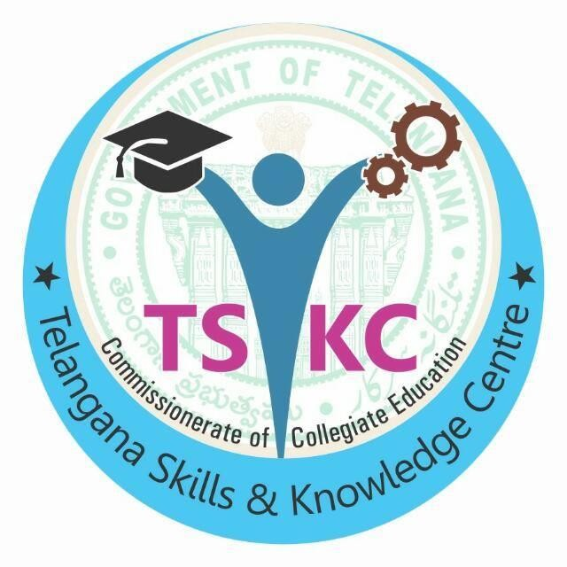

TSKC REPORT ACADEMIC YEAR (2018- 2019)

ACTIVITIES CONDUCTED BY
DEPATMENT OF TSKC
SEPTEMBER 2018 ONWARDS

INDEX : TSKC ACTIVITIES ACADEMIC YEAR (2018-19)

Sl. no | Date | Event/Program | Topic/Objective | Resource Person | Stud ents atten  ded | venue
1 | 26.10.2018 & 27.10.2018 | A&R training session by TASK | Aptitude and Reasoning | K Kavya | 29 | GDC Bodhan
2 | 26.02.2018 to 06.03.2018 | Mahendra Pride Classroom Training | Job Oriented Skills | M Srihari | 55 | GDC Bodhan
3 | 26.09.2018 | Jio Placement certified course | Jio Placement | Ramesh | 5 | Jio Office
4 | 18.04.2019 | Gillette Blade placement | Placement | Naveen | 35 | GDC Bodhan

A&R training session by TASK

To enhance the employability skills and get opportunities in the job market we have tie-up with TASK and they are provided 2 days A&R Training Programme in our college. The Resource person Sri K Kavya Taken classes for this course with examples and successfully completed. The duration for this course was from 26th Oct 2018 to 27th Oct 2018. The objective of this course is to enable them improve their skills and it become self confidence to grab jobs in modern generation and to attend any competitive exams now a days.

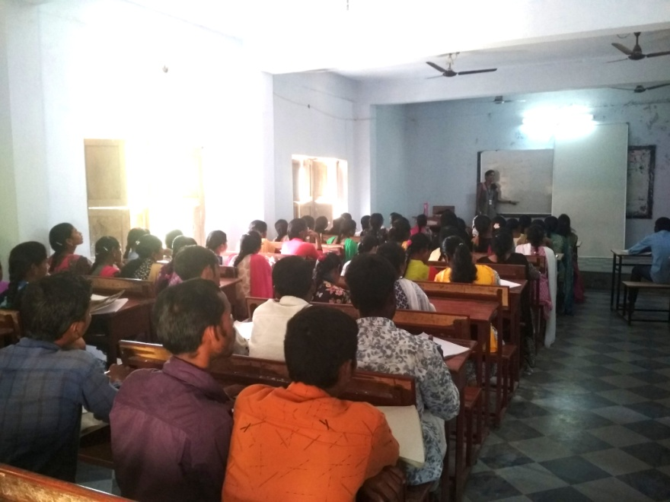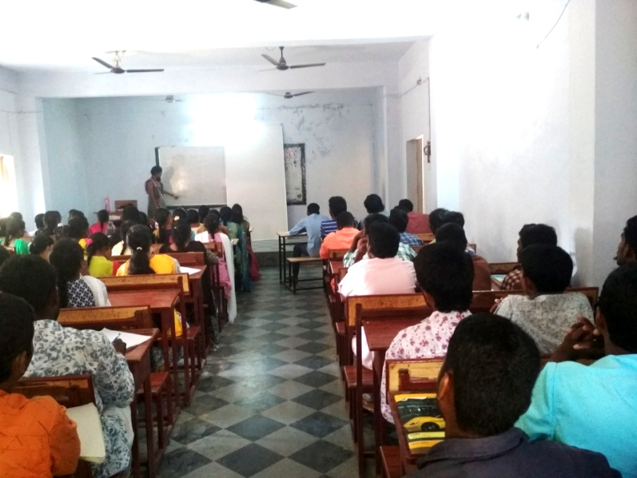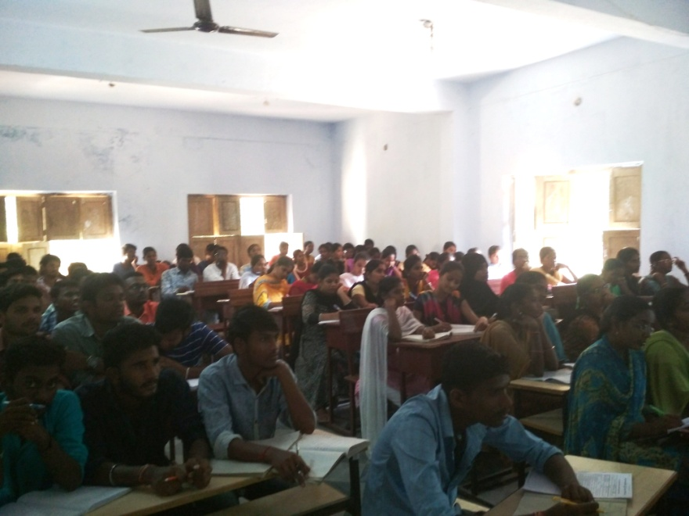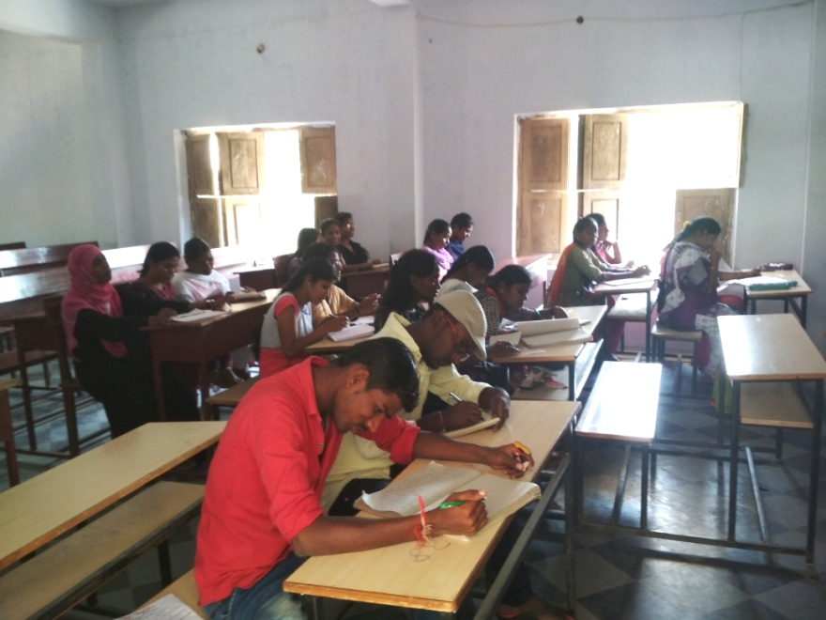

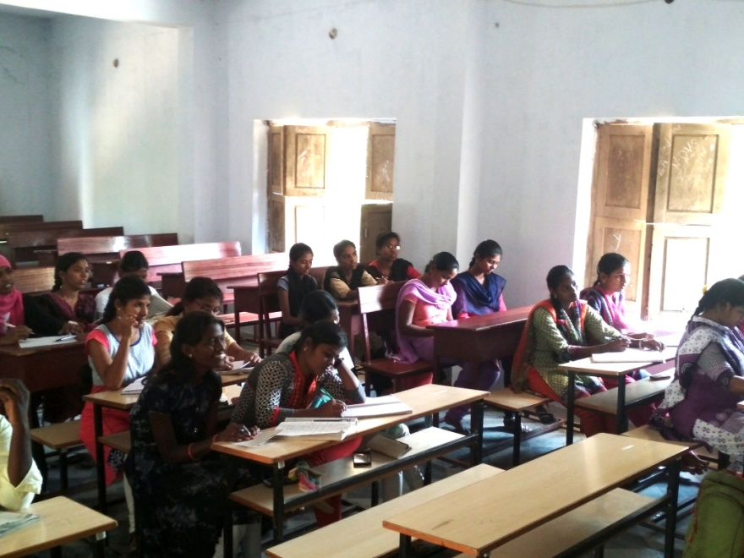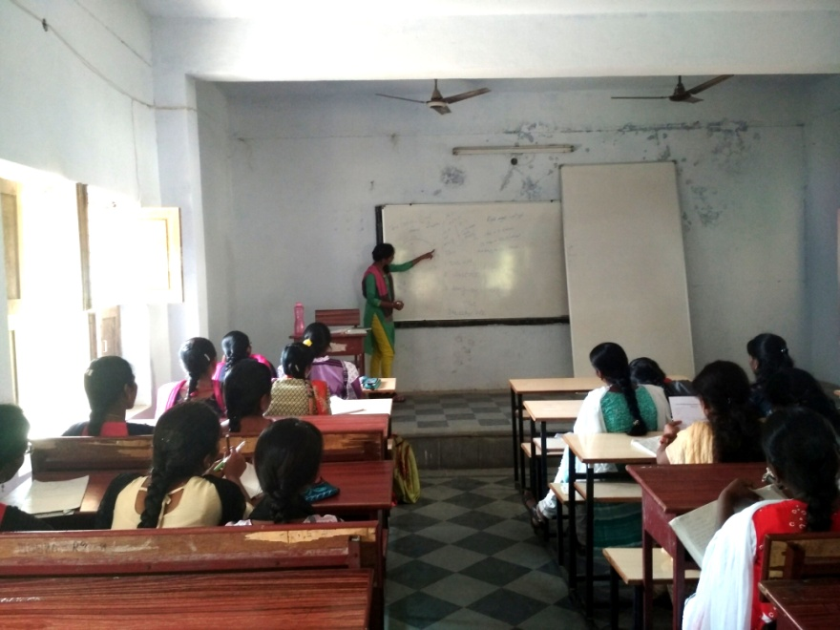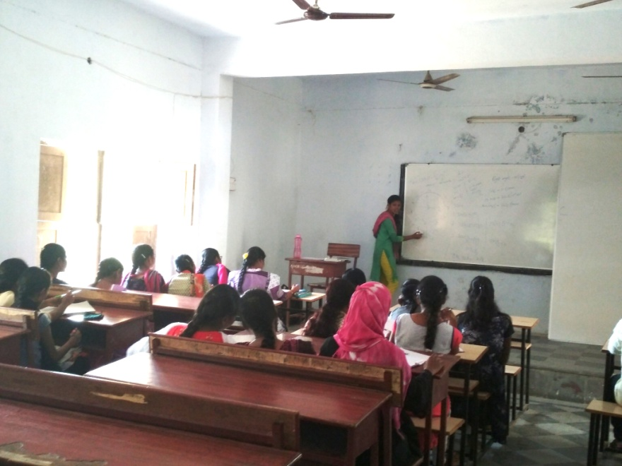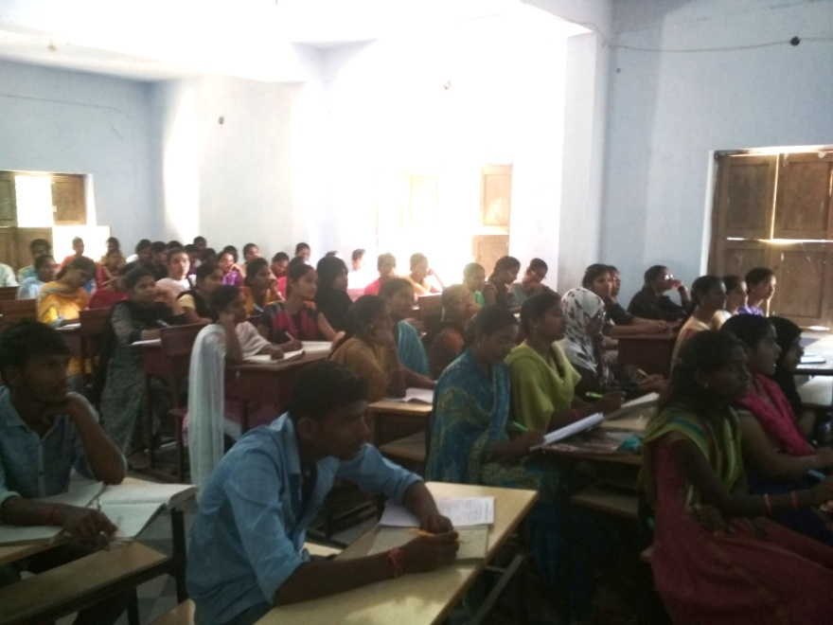

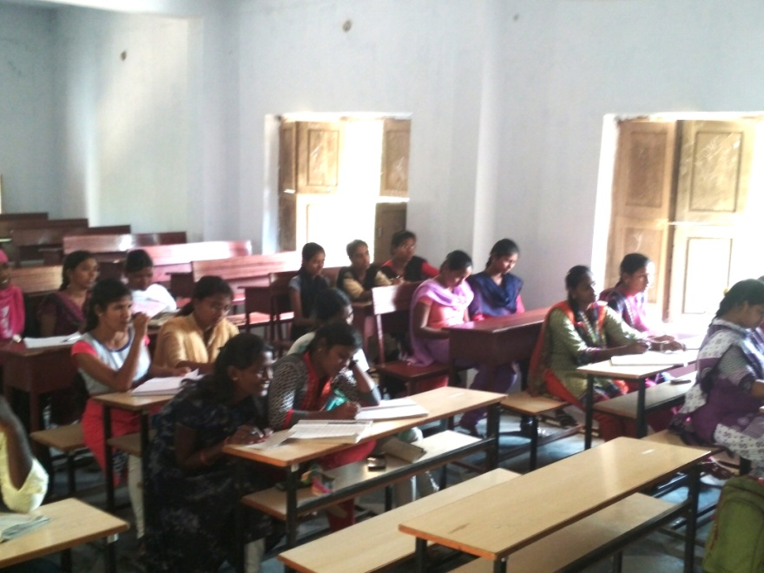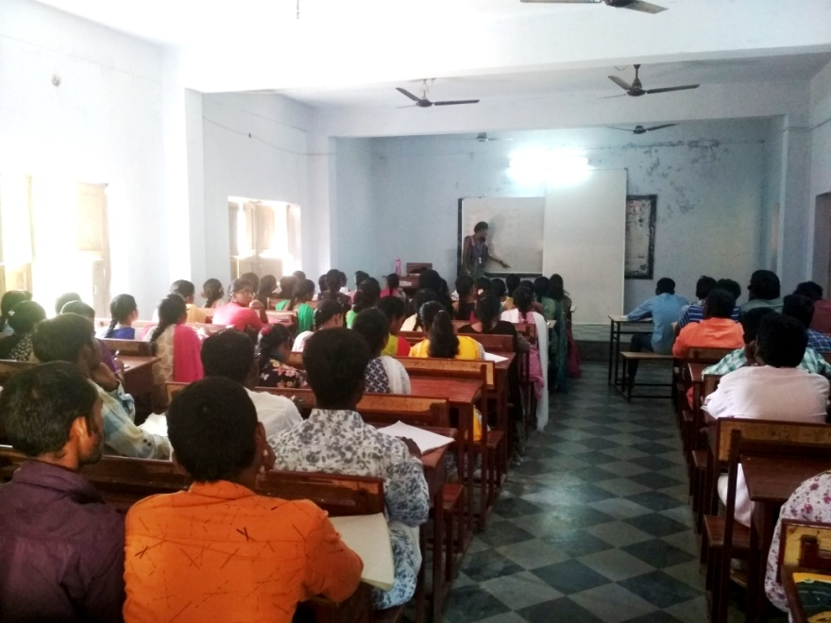
Mahendra Pride Classroom Training

To enhance the employability skills and get opportunities in the job market we have tie-up with TASK and they are provided 7 days Mahendra Pride programme in our college. The Resource person Sri T Srihari Taken classes for this course with activities and successfully completed and certificates given to the students. The duration for this course was from 26th Feb 2019 to 06th March 2019. The objective of these courses is to enable them improve their skills and it become self confidence to grab jobs in modern generation.

Day Wise Activities
Day 1
This is Me +I am Unique
India, My Country

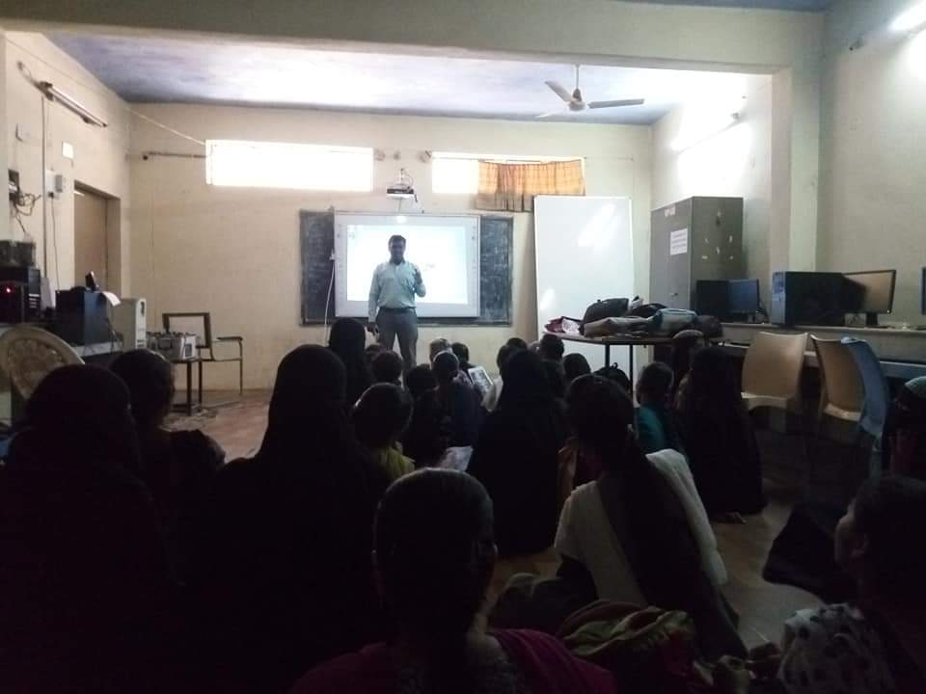

Day 2
Body Language, Grooming & Hygiene
Point of View
Teamwork

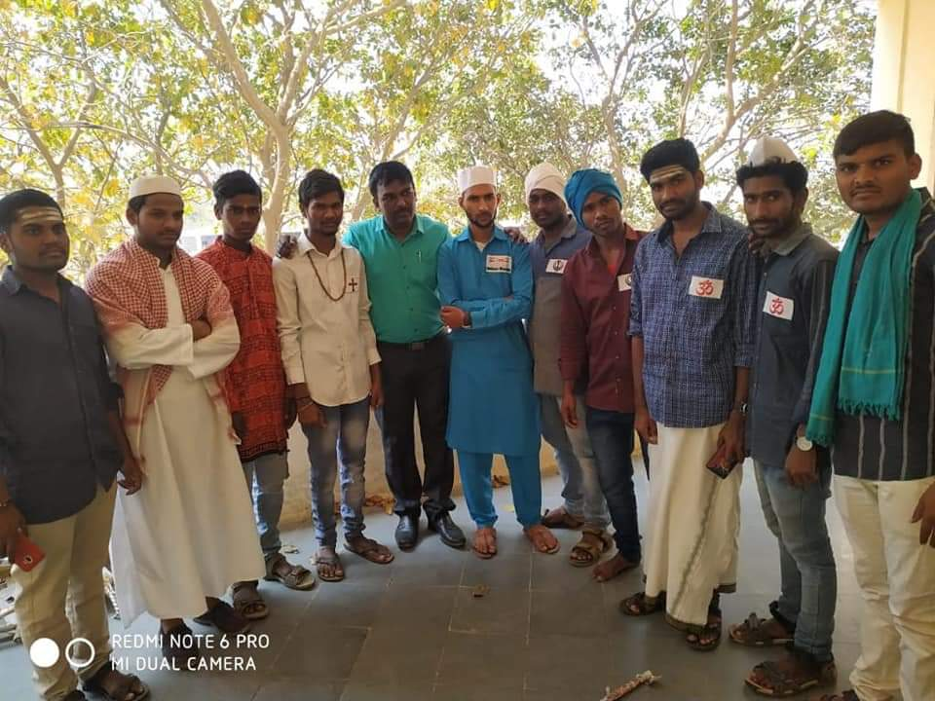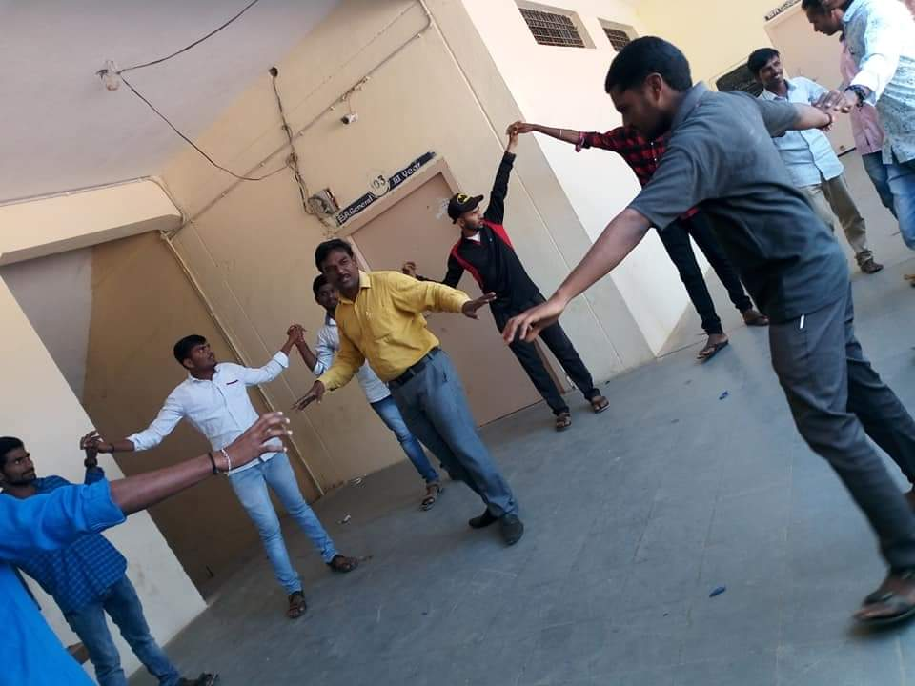

Day 3
Story Writing
I am Limitless
Interview Preparation
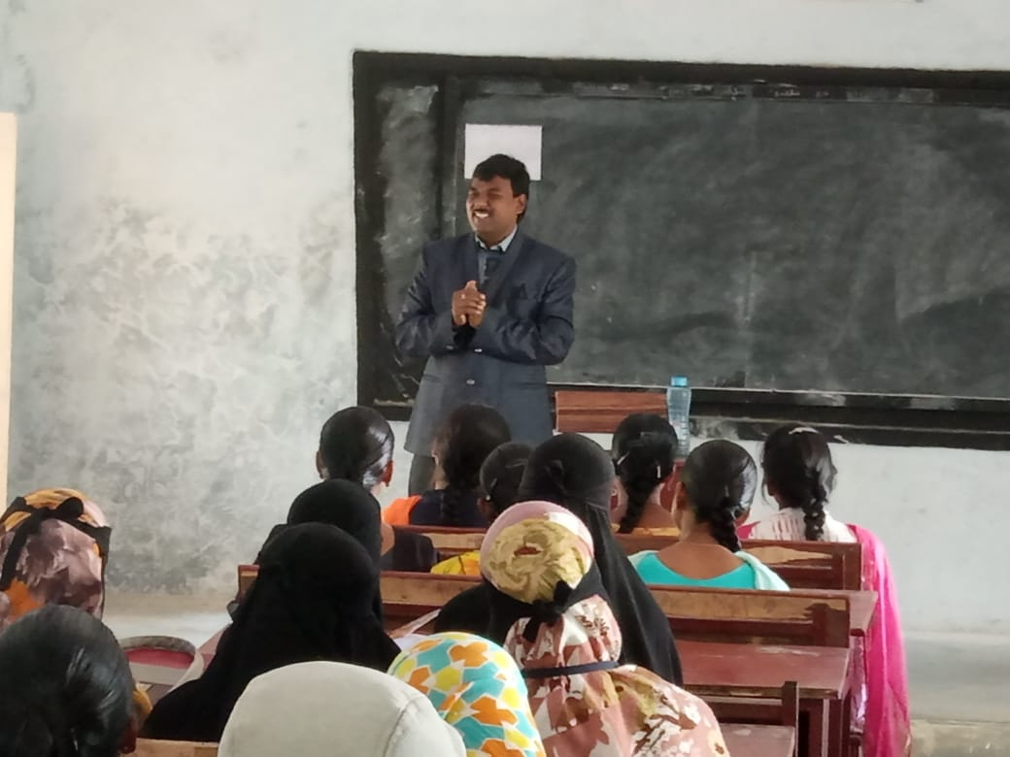

Day 4
India, My Country - Presentation
Time Management
Kindness Boomerang - Adv level

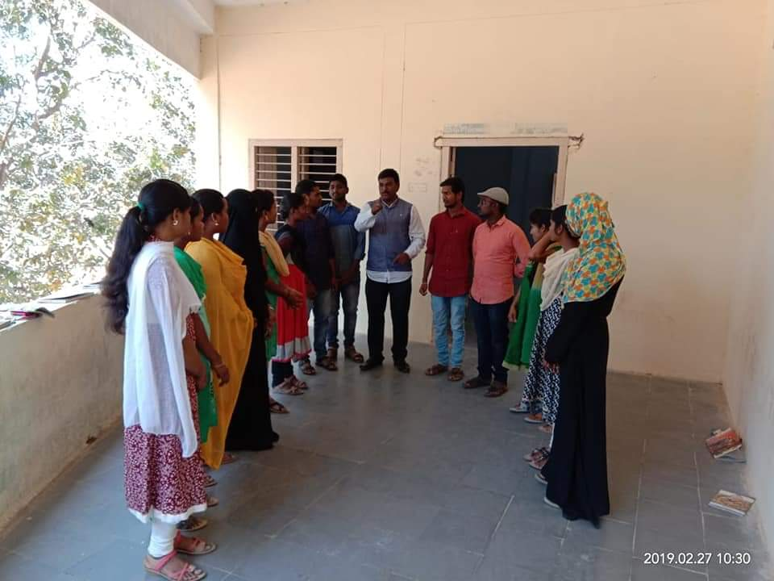

Day 5
Goal Setting & Ownership
Money Management
Professional Ethics
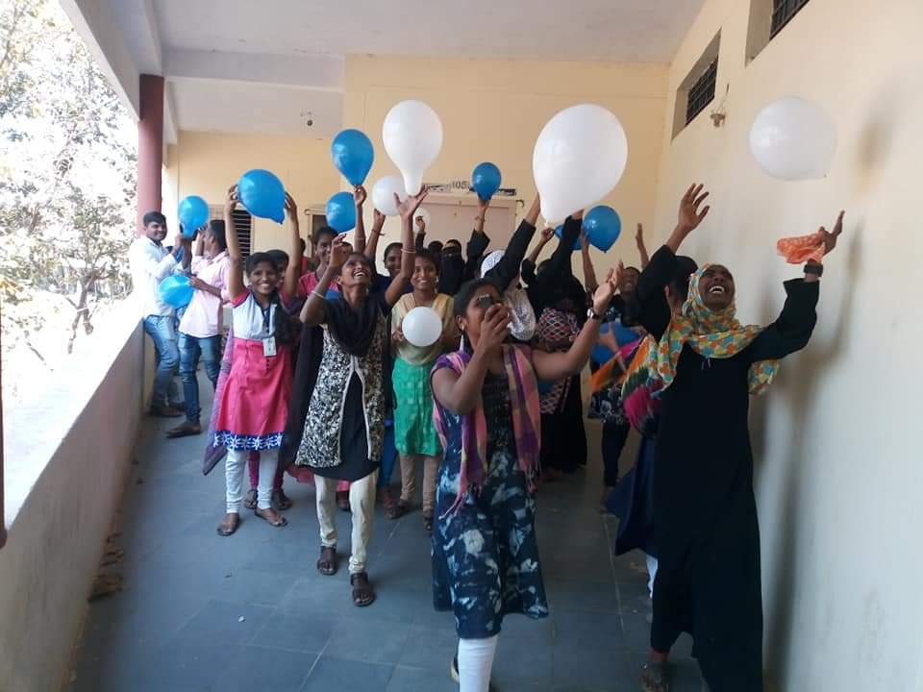

Day 6
Extempore (Basic+ Intermediate)
Group Discussion
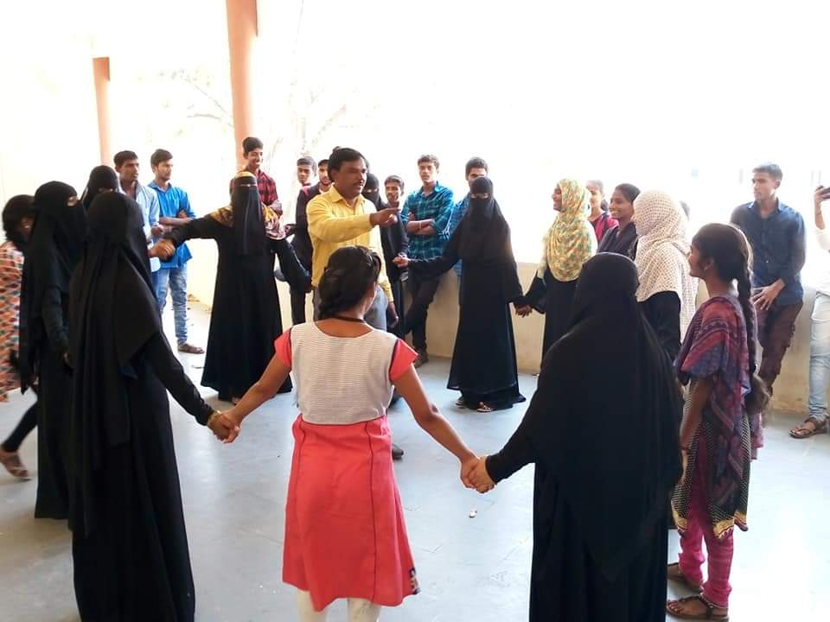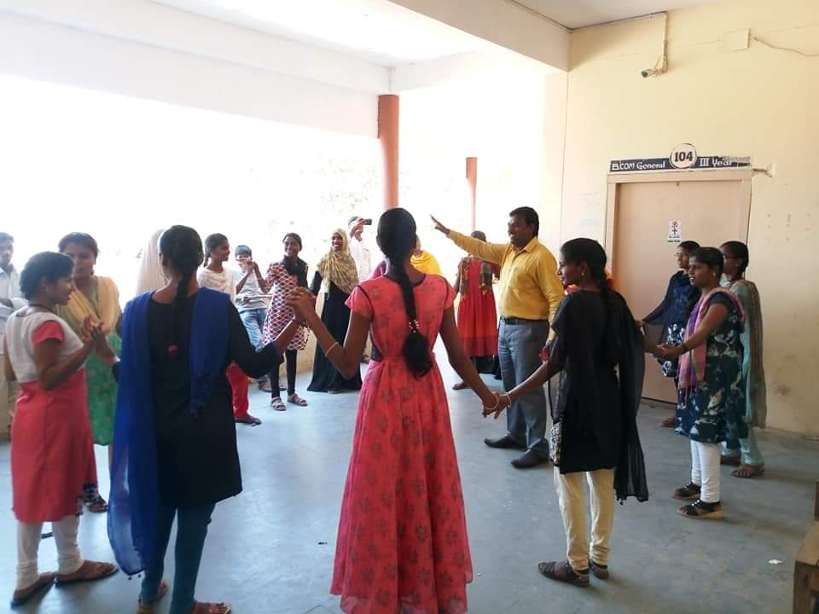

Day 7
Mock Interviews

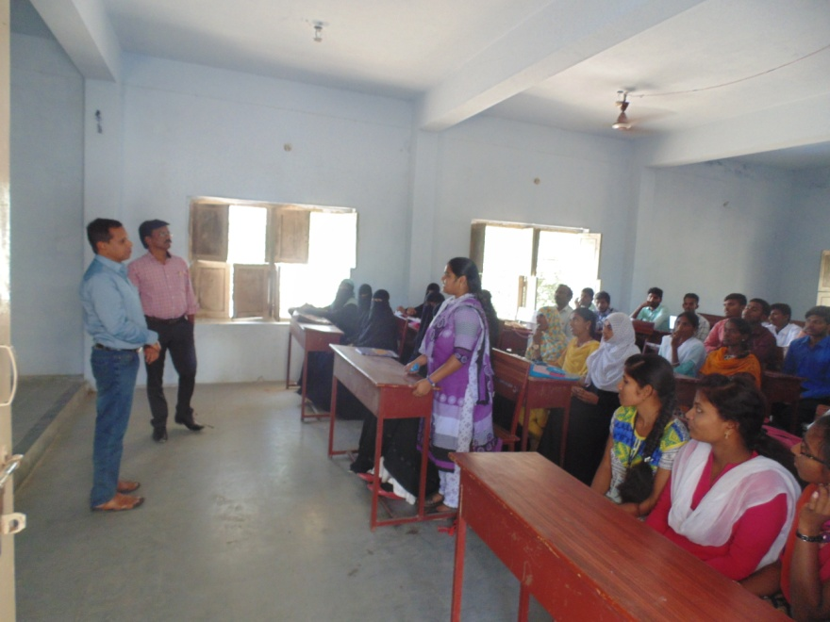

All Activities of Mahindra Pride

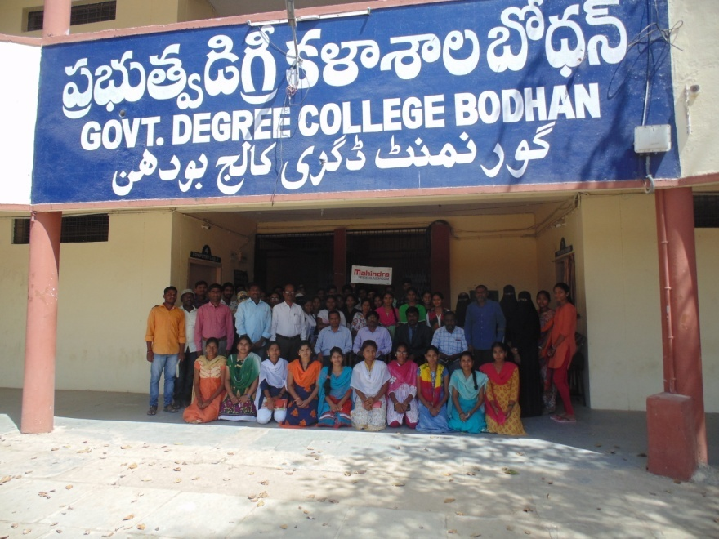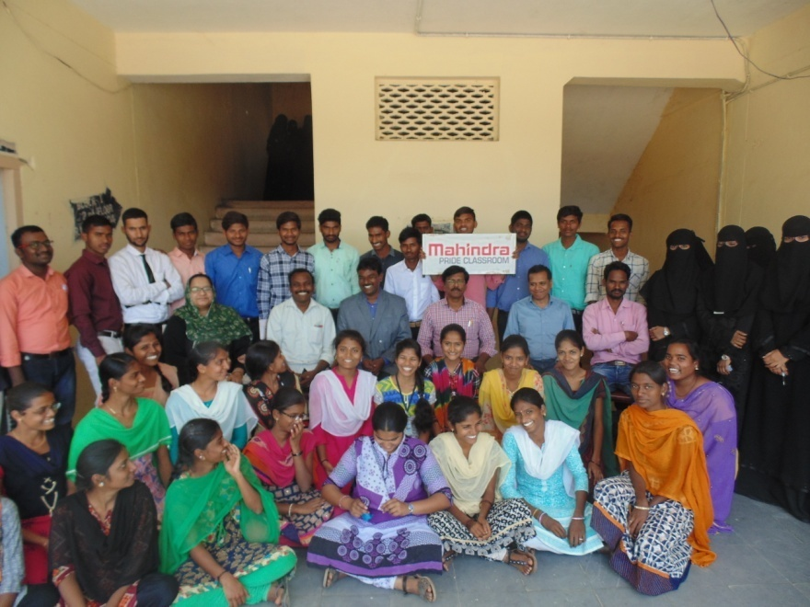

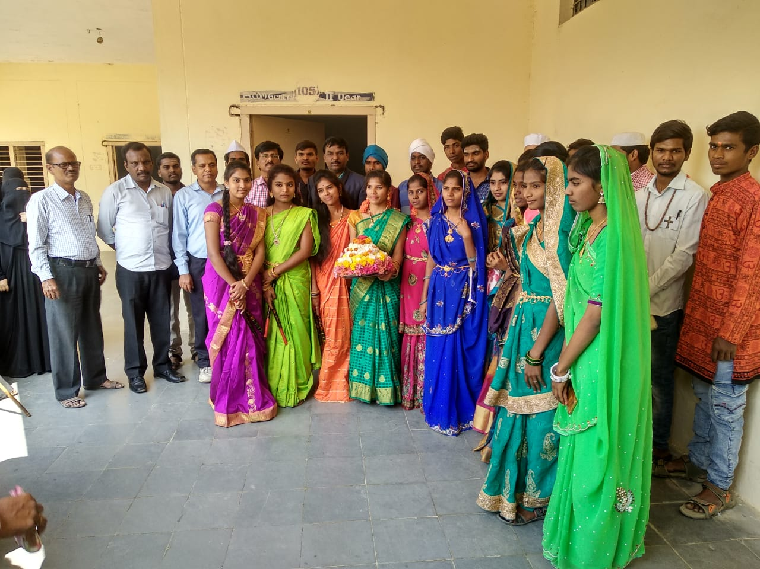

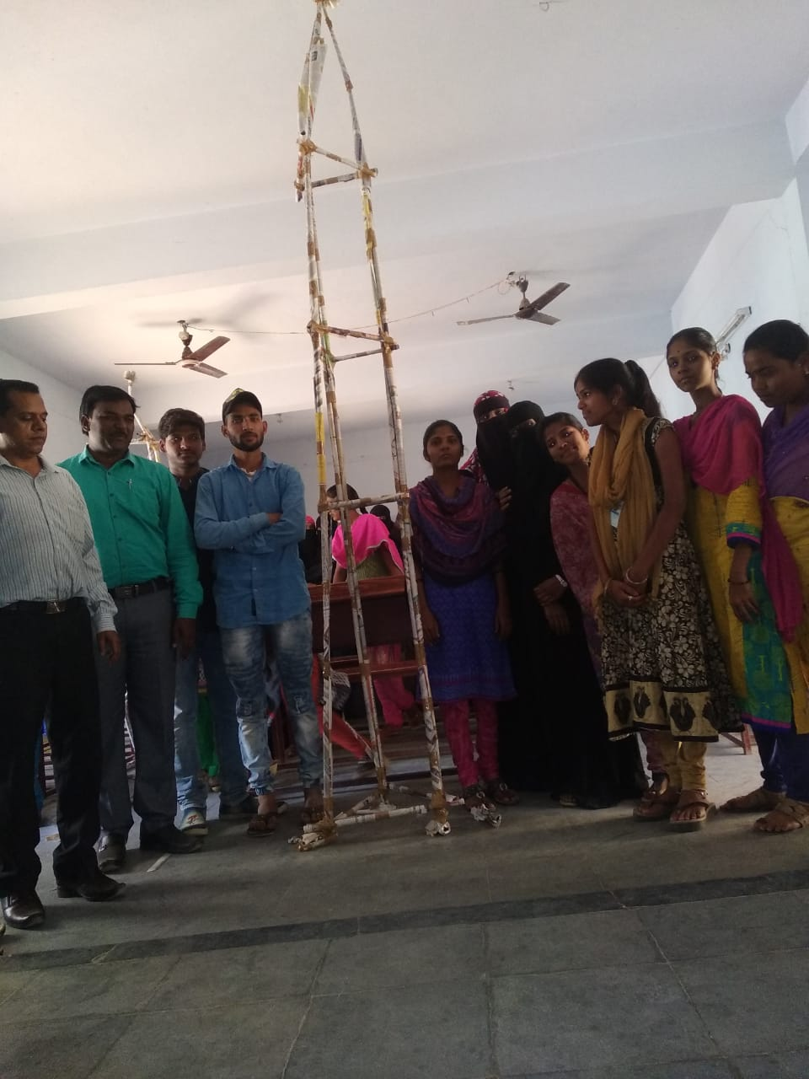

Jio Placement certified course

Jio Company was planed placements based on the certified by their three days training at their head quarter in Bodhan. For this opportunity our college five students were utilized, and they were attended that training programme at their head Quarter in Bodhan. Out of these five members three members are selected and certified.

Gillette Blade placement

Gillette Blade Company was planed placements in our college. They are intracted with our college final year students and taken personal interview in our college premises. They were intimated us that the results was communicated to the selected candidate personally by phone call or through mail.

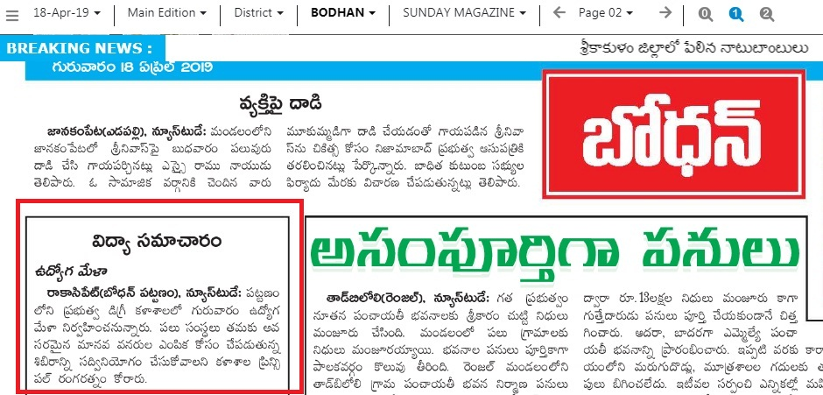

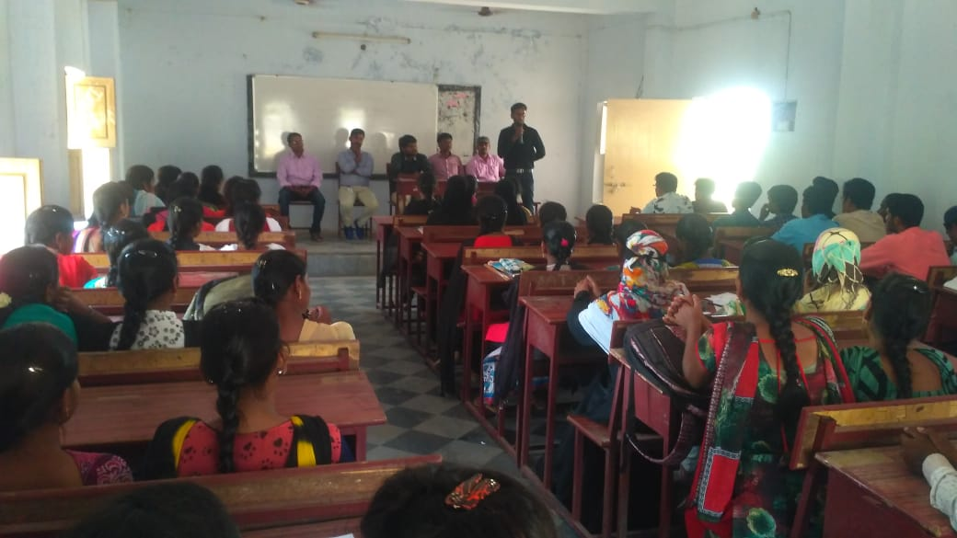

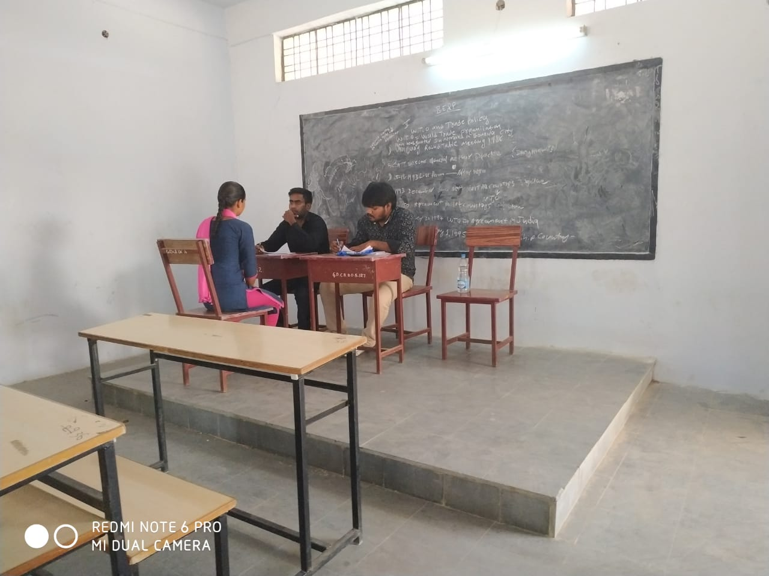

***THANK YOU***

