Best Practices

Title of the Practice: Helping hands.
Goal and Context: To help the poor students who are unable to pay their exam fees and providing other financial support.
Practice:
One donation box is placed in front of the Principal chamber. Lecturers, Students and other visitors donate the amount as their wish. The collected amount is given to poor students. 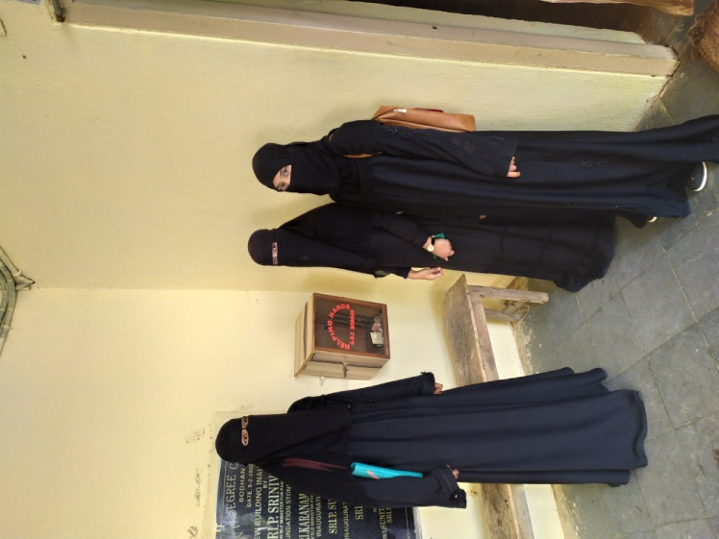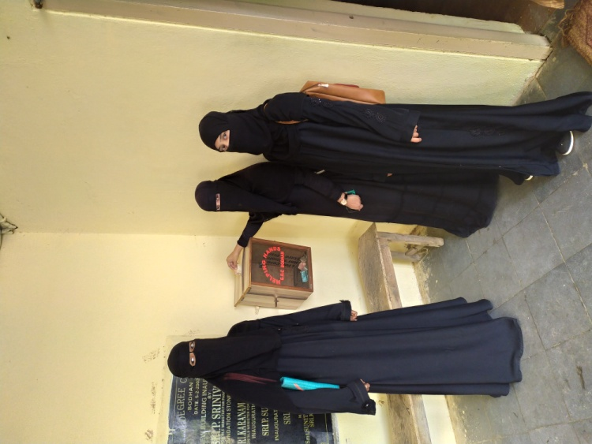

Final Year Students donating in Helping Hands Box.

Title of the Practice: Adoption of Social Welfare Hostels (for School Children).
Goal and Context: To motivate poor and first generation educators, in most of the cases, towards the higher education and reduce the drop out ratio in the school level.
Practice:
Lecturers and selected Students have been visiting the Hostel in the weekends and interact with students. The team conducts counseling, doubts clarification, personality development programmes, spoken English and Co-curricular activities.
Evidence of Success:

The performance of the students in the above hostels has been improved in the curricular and co curricular activities.
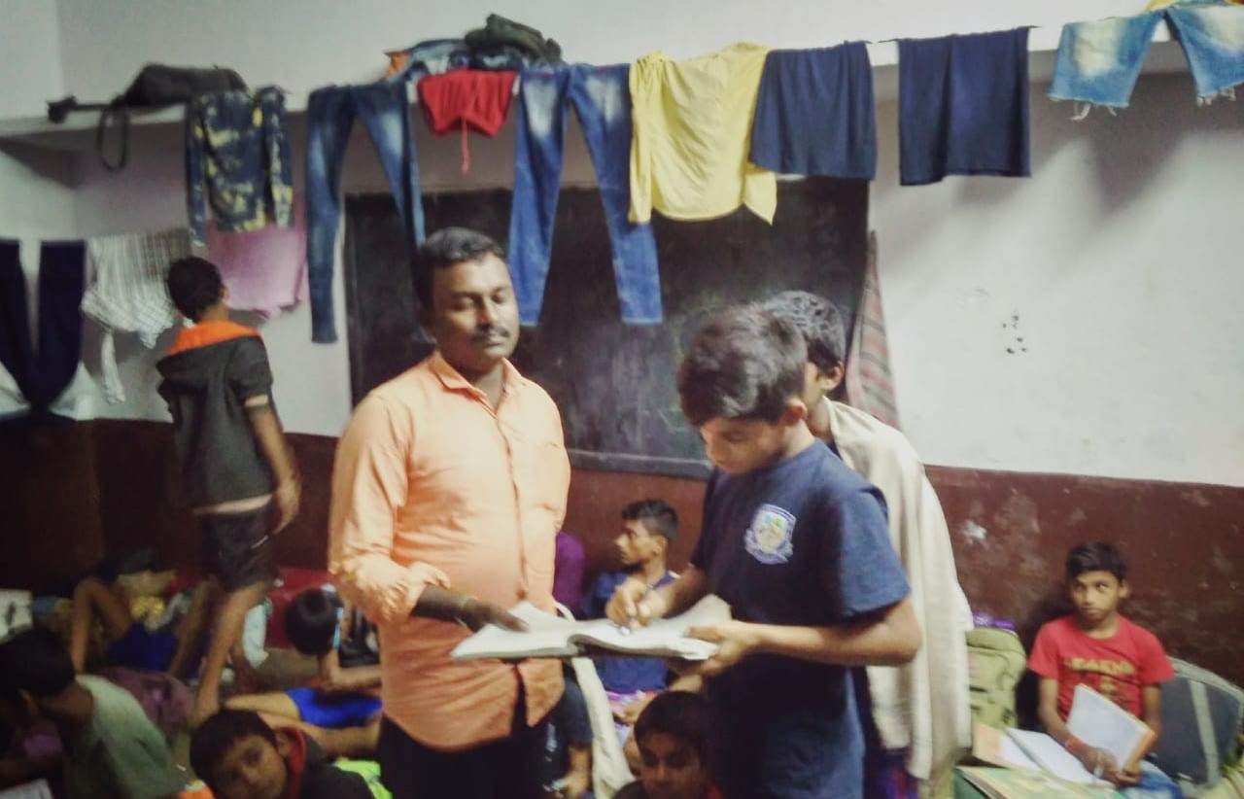

Pruthvi BA student teaching SC hostel students.
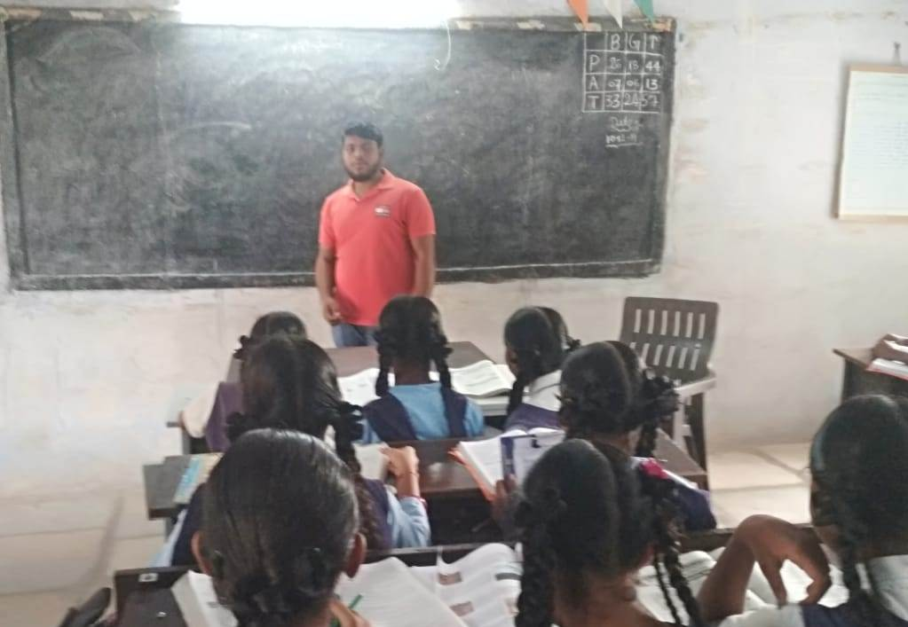

Bhupal teaching VII class students at MSC farm school.

