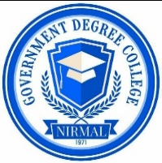
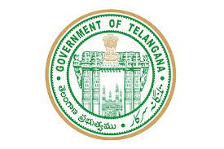 BROCHURE OF ADD-ON COURSE

GOVT. DEGREE COLLEGE, NIRMAL

Accredited by NAAC ‘B’ grade
ISO 9001:2015 Institution
(Affiliated to Kakatiya University)

Add-on Course in Written Communication
ORGANIZED BY

DEPARTMENT OF ENGLISH

FROM 18.04.2022 TO 05.05.2022
COURSE FEATURES:
- All the students of the college can apply
- Course cover the necessary written communication skills
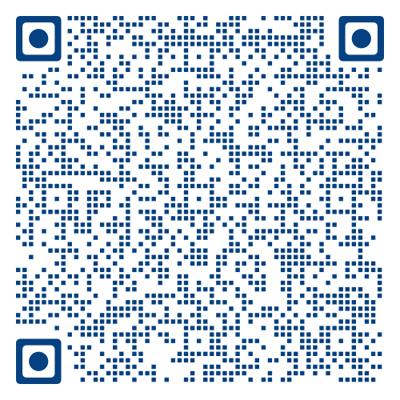
- Course runs 30 hours
- Course-end exam will be on-line mode
- 100% attendance is necessary
Register at Resource Persons (↓) OR Scan the QR Code (→)

P. ASHOK
LECTURER IN ENGLISH
94414 60234
Dr. M. RAJITHA
LECTURER IN ENGLISH
97018 09374

COURSE DIRECTOR

U.RAVI KUMAR Asst. Professor
CONVENER

Dr. J.BHEEMARAO
PRINCIPAL

