LEGAL AWARENESS PROGRAMME (2016-17)
Judge Shyam Sunder is the chief guest of the programme and many of the senior lawyers addressed in the programme about different laws and sections which are helpful to the girls students.

Judge Shyam Sunder addressing the
Students.

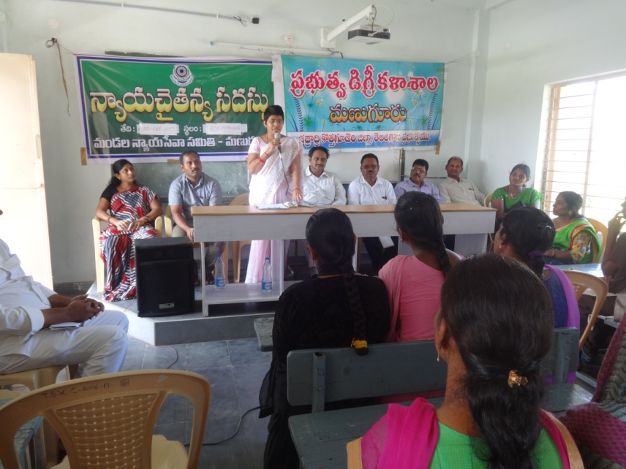

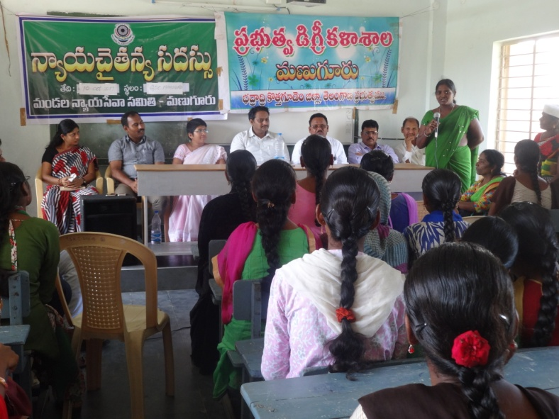

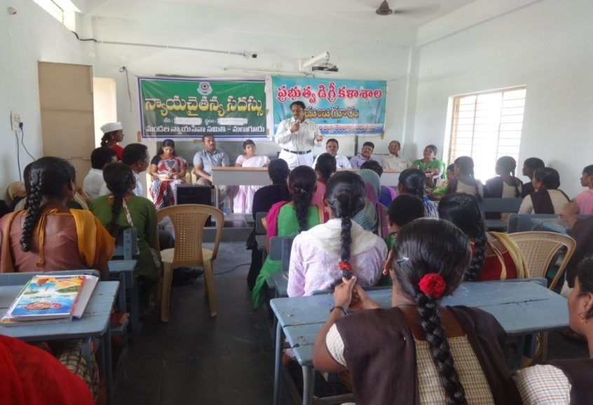

LEGAL AWARENESS PROGRAMME (2019-20)
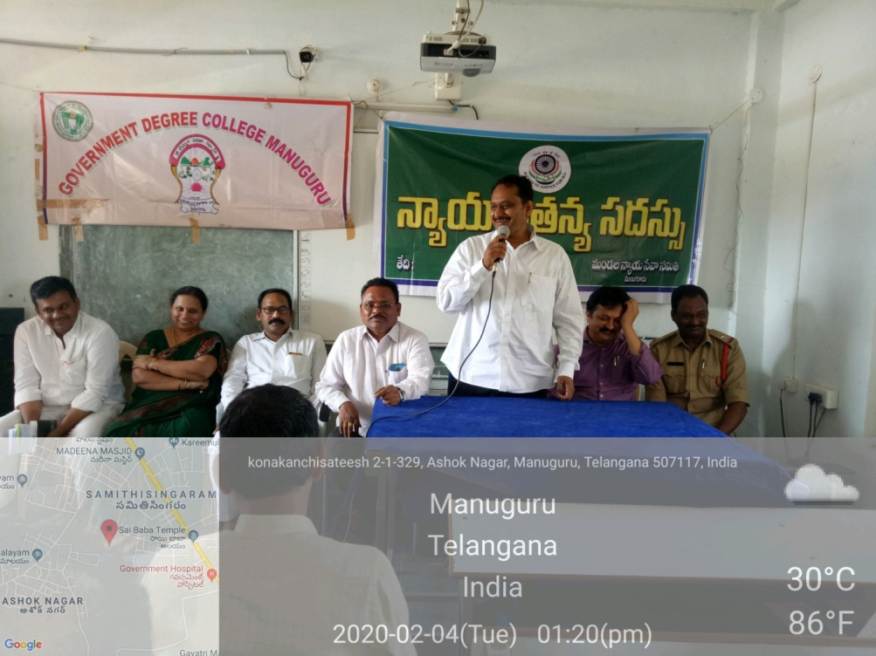

This programme creates awareness to girl students about
Some acts and sections, the judge and the lawyers addressed
The students and explained them some Acts, some of them are
- The Prohibition of Child Marriage Act, 2006.
- Special Marriage Act, 1954.
- Dowry Prohibition Act, 1961.
- Indian Divorce Act, 1969.
- Maternity Benefit Act,1861.
- Medical Termination of Pregnancy Act,1971.
- Sexual Harassment of Women at Workplace (Prevention, Prohibition and Redressal) Act, 2013.
- Indecent Representation of Women(Prevention) Act,1986
- National Commission for Women Act, 1990
- Equal Remuneration Act, 1976

