The following resources are available in the institution for Divyangjan (Differently Abled Faculty and Students)
Physical facilities
Ramp / Rails
Braille Software/facilities
Rest Rooms designated
Scribes for examination

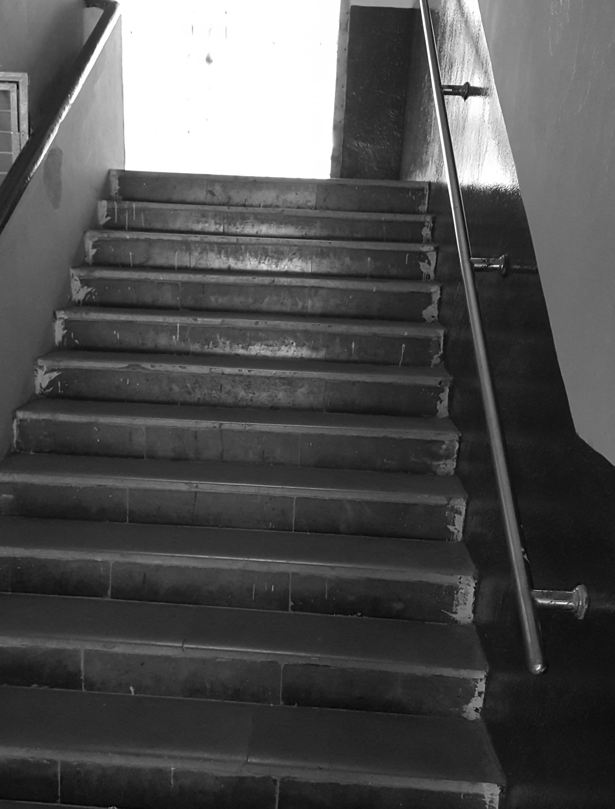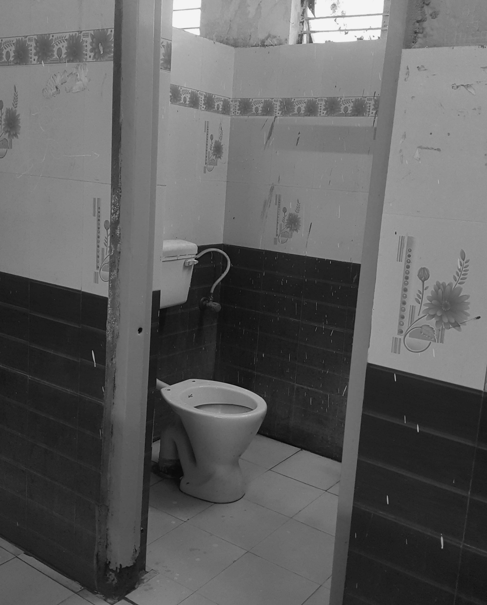
Physical facility and Rest Room for Differently abled persons

