Dr.B.R.R.GOVT COLLEGE, JADCHERLA
COMMERCE DEPARTMENT

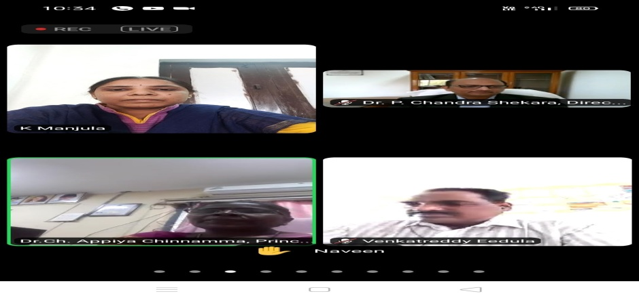
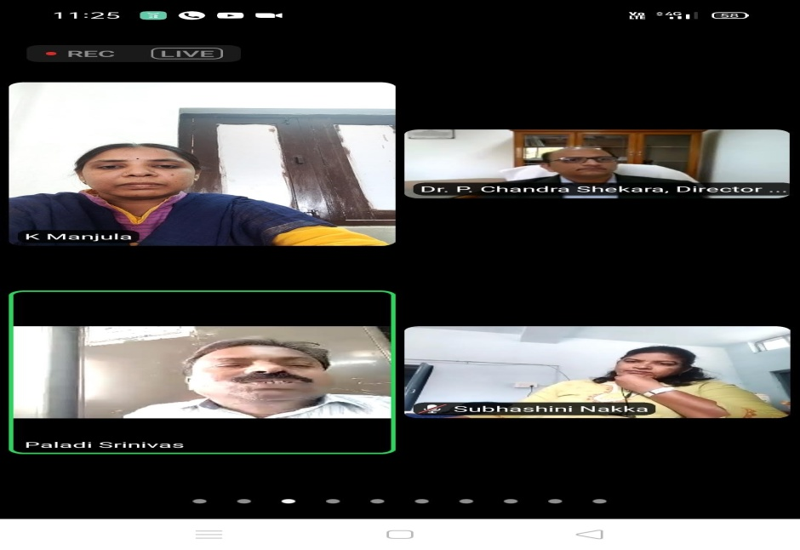

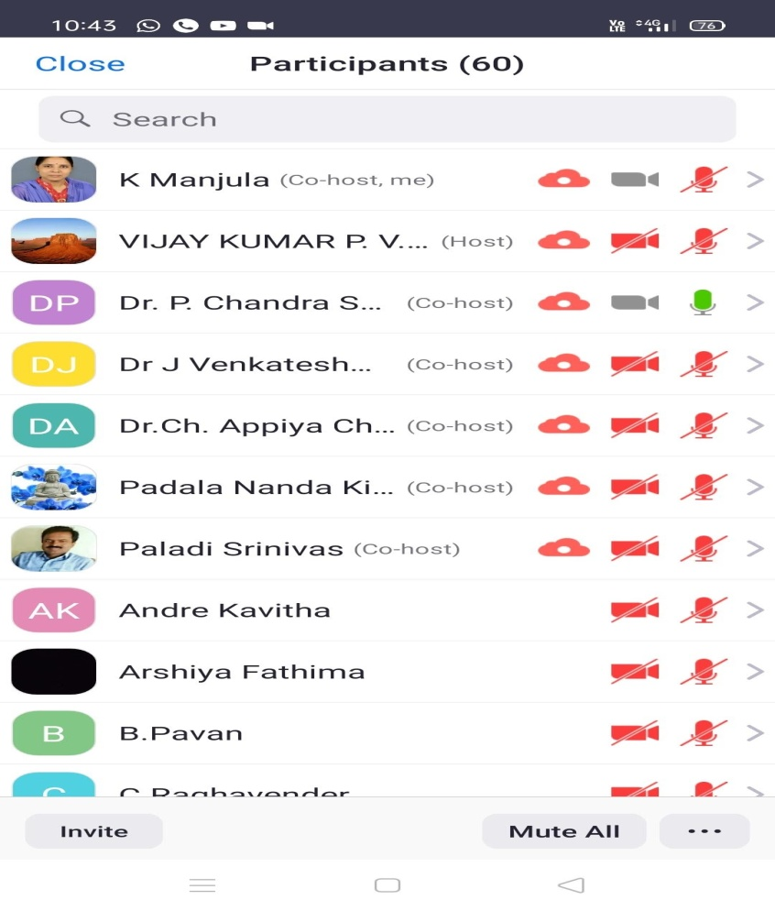
DATE: 24-03-2021
Department of Commerce organized online awareness program on “ Opportunities in Agri-Business” as a part of Entrepreneurial Development program.
Resoure Person:Dr.P.Chandrashekara.
-Director General –MANAGE.

