Dr.B.R.R.GOVT DEGREE COLLEGE, JADCHERLA
COMMERCE DEPARTMENT
COMMERCE QUIZ

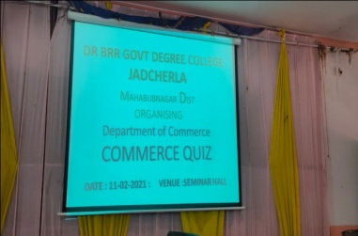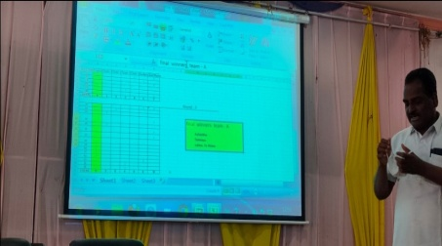
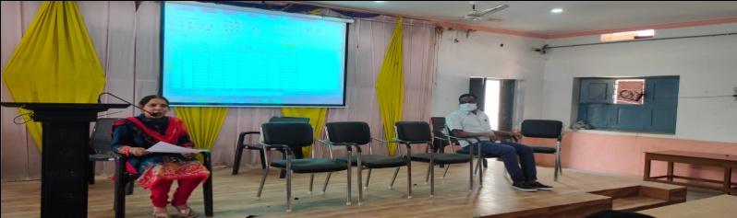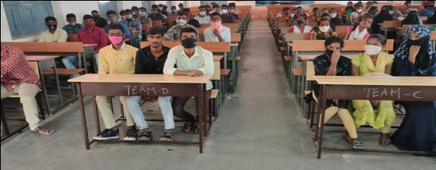
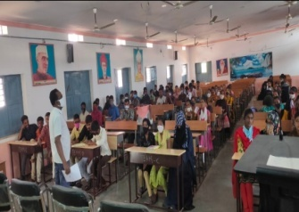
DATE:11-02-2021
The Department of commerce organised commerce quiz competition in the seminar hall with 5 teams and 3 rounds.

