CAMPUS PLACEMENT DRIVE: The department of commerce exclusively takes responsible of the college branding, building corporate relationships, training, counseling and motivating the students and also placements drive organized by ICICI Bank on 17-09-2019.
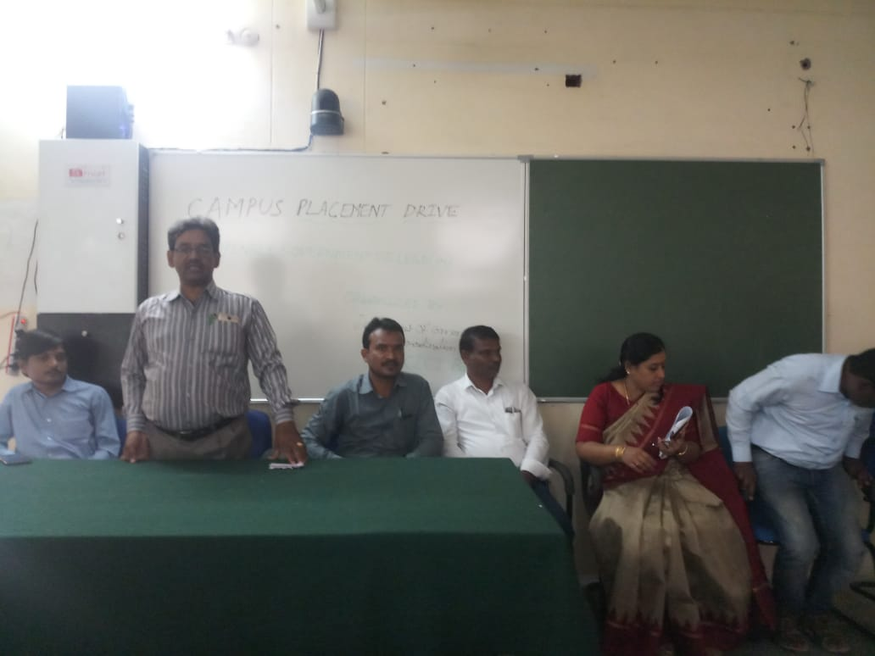 | 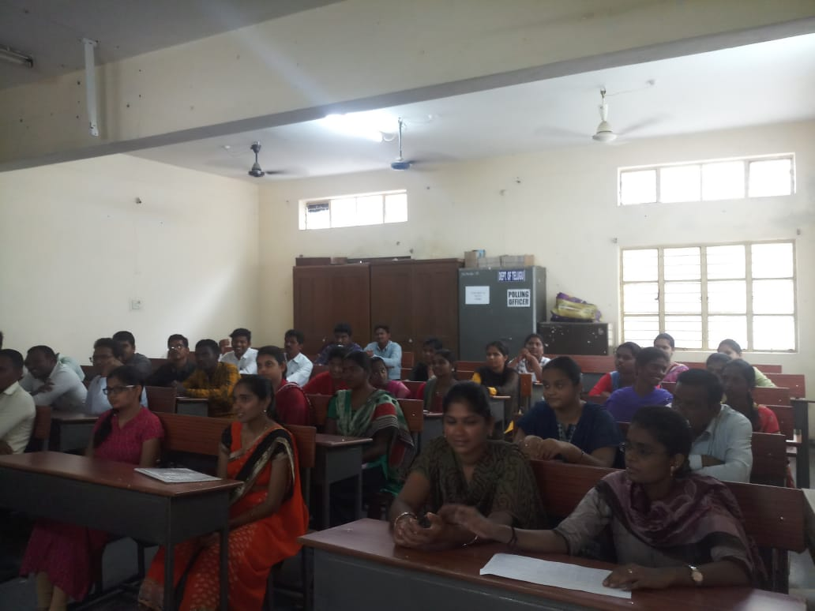
Addressing by Dr.G.Raja Reddy Principal and HR Manager B.Venkatesh ICICI Bank in inaugural session of campus placement drive 17-09-2019 | Graduates are participating in campus placement drive organized by Dept of Commerce, Pingle Govt. College for Women, Warangal Urban-TS

